0BDRAFT Wildfire Mitigation Plan
March 2025
PREPARED FOR
Mora-San Miguel Electric Cooperative

PREPARED BY
SWCA Environmental Consultants

DRAFT Wildfire Mitigation Plan

Prepared for
Mora-San Miguel Electric Cooperative
Highway 518 Main Street
Mora, New Mexico 87732
Attn: Les Montoya

Prepared by
SWCA Environmental Consultants
7770 Jefferson St NE, Unit 410
Albuquerque, New Mexico 87109
(505) 254-1115
www.swca.com

SWCA Project No. 00092647

December 2024

Contents
1 Introduction 1
1.1 Purpose of the Plan 1
1.2 Objectives of the Wildfire Mitigation Plan 1
1.3 Utility Profile and History 2
1.4 The Service Area 2
2 Wildfire Risk Analysis 5
2.1 Topography, Vegetation, and Climate 5
2.2 Wildfire History and Outlook 6
2.3 Wildfire Ignition Risk 9
2.3.1 Weather 9
2.4 Wildfire Risk within the Service Area 12
2.5 Community Wildfire Risk Reduction Zones 17
2.6 Wildfire Impacts 19
3 Wildfire Mitigation Strategy and Programs 19
3.1 Overview of Fire Mitigation Strategies 19
3.2 Areas of Concern and Prioritized Action Plan 20
3.2.1 Areas of Concern Maps 29
3.3 Grid Resilience and Infrastructure Project 35
3.4 Transmission and Distribution System Operational Practices 37
3.4.1 De-energization – Public Safety Power Shutoff 37
3.4.2 Recloser Operational Practices 38
3.4.3 Situational Awareness 38
3.5 Infrastructure Inspections and Maintenance 39
3.5.1 Definition of Inspection Levels 39
3.5.2 Safety Patrol Inspections of Transmission and Distribution Lines 40
3.5.3 Detailed Inspections of Transmission and Distribution Lines 41
3.5.4 Wood Pole Testing and Inspection 41
3.5.5 Substation Inspections 41
3.6 Integrated Vegetation Management 42
3.6.1 Vegetation to Conductor Clearance 43
3.6.2 Vegetation Trimming Standards 44
3.6.3 Vegetation Trimming and Inspection Schedule 44
3.6.4 Hazard Trees 44
3.6.5 Revegetation Practices 45
3.7 Fire Mitigation Construction 45
3.7.1 Avian Protection Program 45
3.8 Emerging Technologies 46
4 Emergency Response 46
4.1 Preparedness and Response Planning 46
4.1.1 Emergency Management Communication and Coordination 47
4.1.2 Jurisdictional Structure 47
4.1.3 Public Agency and Customer Communications for Outages 48
4.1.4 Community Outreach 48
4.1.5 New Mexico Electric Cooperative Mutual Aid Agreement 48
4.2 Restoration of Service 49
4.2.1 Service Restoration Process 49
5 Performance Metrics and Monitoring 50
5.1 Plan Accountability 50
5.2 Monitoring and Auditing of the WMP 50
5.2.1 Identifying Deficiencies in the WMP 50
5.3 Performance Metrics 50
5.4 Programmatic Quality Assurance/Quality Control Processes 51
5.4.1 Transmission and Distribution System Inspection Quality Control Process 51
5.4.2 Vegetation Management Quality Control Process 52
5.5 Plan Approval Process 52
5.5.1 Public Comment 52
5.5.2 Board Presentation 53
6 References 54

Appendices
Appendix A Plan and Mapping Disclaimers
Appendix B Integrated Vegetation Management Procedures, Policies, and Plan

Figures
Figure 1. Land Ownership across the MSMEC Service Area. 4
Figure 2. The Quantitative Wildfire Risk Assessment Framework. 5
Figure 3. Historic Wildfire Perimeters 1970–2024. 8
Figure 4. Ignition Occurrence History by Ignition Cause. 10
Figure 5. Density of Past Ignition Occurrences. 11
Figure 6. Wildfire Risk to Potential Assets. 13
Figure 7. Wildfire Hazard Potential. 14
Figure 8. Wildfire Burn Probability. 15
Figure 9. Wildfire Intensity (Conditional Flame Length). 16
Figure 11. Community Wildfire Risk Reduction Zones. 18
Figure 10. MSMEC Areas of Concern. 32
Figure 11. MSMEC areas of concern in the northwest portion of the MSMEC service area. 33
Figure 12. MSMEC areas of concern in the northeast portion of the MSMEC service area. 34
Figure 13. MSMEC areas of concern in the southwest portion of the MSMEC service area. 35
Figure 14. MSMEC areas of concern in the southeast portion of the MSMEC service area. 36

Tables
Table 1. Land Ownership Entities within the MSMEC Service Area. 2
Table 2. Asset Overview. 3
Table 3. Acres Burned in the MSMEC Service Area by Year since 1970. 6
Table 4. Mitigation Strategies/Activities. 19
Table 5. Prioritized Areas of Concern and Action Plan 21
Table 6. MSMEC’s Planned Activities, Projects, and Budget Allocations under the GRIP Initiative 35
Table 7. Inspection Program Schedule. 40
Table 8. Performance Metrics. 51

Introduction
This Wildfire Mitigation Plan (WMP) has been developed by Mora-San Miguel Electric Cooperative (MSMEC) to guide wildfire mitigation activities for the Cooperative. The state of New Mexico currently lacks specific requirements for a WMP; therefore, MSMEC has developed this plan to align with industry best management practices. While WMP requirements are being developed and may vary by state, this plan outlines goals for implementing operational policies and procedures for preventing, preparing for, and responding to wildfire events. This plan is expected to undergo annual evaluation or updates requiring board approval.
Fire mitigation is a critical aspect of MSMEC’s operations. The utility’s existing policies, programs, and procedures are designed to manage or reduce wildfire risk, either directly or indirectly. Over time, MSMEC will implement additional fire mitigation programs and procedures to adapt to changing fire conditions. MSMEC will leverage technological advancements and enhanced operational practices to further reduce ignition risks and wildfire impacts.

Purpose of the Plan
The WMP establishes MSMEC’s strategies, programs, and procedures to mitigate the risk of wildfire ignitions and subsequent damage caused by both natural and human-caused wildfires. It identifies wildfire risk to assets by considering the unique characteristics of its service territory, including topography, weather, fuels (vegetation), infrastructure, and communities. Included in the WMP are objective-based plans to implement specific actions for improving system resilience to wildfire, reducing the probability of ignition, and managing vegetation to eliminate wildfire hazards. Wildfire mitigation actions encompass the maintenance, upgrade, and inspection of MSMEC assets and the management of vegetation in the right-of-way (ROW) containing these assets.
The purpose of the WMP is to reduce liability to MSMEC and protect nearby communities within the service area.
The WMP is reviewed and approved by MSMEC's Board of Directors as necessary, while the General Manager and Vegetation Operations Supervisor are responsible for its implementation.

Objectives of the Wildfire Mitigation Plan
The primary objective of the WMP is to minimize the likelihood of MSMEC’s assets serving as the origin or contributor in the ignition of a wildfire through the creation of an actionable plan that increases the dependability and safety of MSMEC’s infrastructure and operations. The mitigation programs and strategies outlined within this WMP will be in compliance with current New Mexico State law and National Electric Safety Code (NESC) regulations and guidelines. To assist in the development of the plan, MSMEC completed a detailed wildfire risk analysis and evaluated leading industry procedures and technologies to reduce the probability of service interruptions and reduce the risk of wildfire ignitions.
To ensure objectives are met, the effectiveness of mitigation strategies will be measured through an annual evaluation of certain performance indicators (see Chapter 5). MSMEC will evaluate the need to substitute, modify, or remove any action, program component, or protocol that is deemed unnecessary or ineffective.

Utility Profile and History
Established in 1940 and energized in 1949, MSMEC has a long-standing commitment to improving the lives of its member owners. With a mission to deliver safe, reliable, and affordable electricity while investing in the communities it serves, MSMEC focuses on excellent member service and clean renewable energy. The cooperative proudly serves 11,180 members across four counties: Guadalupe, Mora, San Miguel, and Santa Fe (New Mexico Rural Electric Cooperatives n.d.)
MSMEC is governed by a dedicated board of trustees representing various districts within its service area. The board consists of Robert Baca, President (District 4: Glorieta, Ojitos Frios, Rowe, San Pablo, Serafina, Valencia); James Ortiz, Vice President (District 3: Anton Chico, Bernal, Ribera, San Jose, Sheridan, Villanueva); Virginia Mondragon, Secretary/Treasurer (District 1: Mora, Cleveland, Holman, Chacon, Guadalupita, Murphy Canyon); Joe C. de Baca, Trustee (District 5: Cowles, Grass Mountain, La Joya, Pecos, Terrero); and Sam Ramirez, Trustee (District 2: Rociada, Sapello, Buena Vista, Rainsville, Trujillo, Watrous, Gallinas) (MSMEC 2024a)
MSMEC's management team is dedicated to supporting its communities by developing partnerships with members, implementing new technology, and ensuring the delivery of smart, clean, and affordable electric power in its expanding service territory. This commitment is reflected in MSMEC's vision to monitor and deliver innovative and sustainable energy solutions, continually enhancing the quality of life for its members (MSMEC 2024b)

The Service Area
The utility service area spans several counties and covers land managed by various entities such as the State of New Mexico, National Park Service (NPS), U.S. Forest Service (USFS), U.S. Fish and Wildlife Service (USFWS), Bureau of Land Management (BLM), and Department of Defense (Table 1; Figure 1). The utility maintains approximately 17,000 miles of distribution lines (Table 2) throughout its territory (BLM 2024; New Mexico Rural Electric Cooperatives n.d.). The utility serves its members from two primary locations: the Main Office in Mora, New Mexico, and the District Office in Pecos, New Mexico. These offices are available for members to pay bills, request new services, connect or disconnect services, and address any service issues or billing concerns (MSMEC 2024b).
Table 1. Land Ownership Entities within the MSMEC Service Area.
Land Ownership | Acres | Percentage of Service Area
BLM | 26,764 | 1.00%
USFS | 398,069 | 14.92%
USFWS | 8,706 | 0.33%
NPS | 7,053 | 0.26%
Department of Defense | 801 | 0.03%
State | 132,663 | 4.97%
Private | 2,093,458 | 78.47%
BNSF Right of Way | 433 | 0.02%
Total | 2,667,950 | 100%
Table 2. Asset Overview.
Asset Classification | Asset Description
Power line ROW | Approximately 17,000 miles of distribution power service lines.
Distribution ROW | MSMEC distribution conductors range from single-phase 7.2 kilovolts (kV) to 3-phase 24.9 kV and are centered within a ROW corridor maintained at a minimum width of 20 feet.
Substation assets | Three substations: Storrie Lake substation and Rowe substation owned by Tri-State; Rainsville substation owned by MSMEC.
Figure 1. Land Ownership across the MSMEC Service Area.
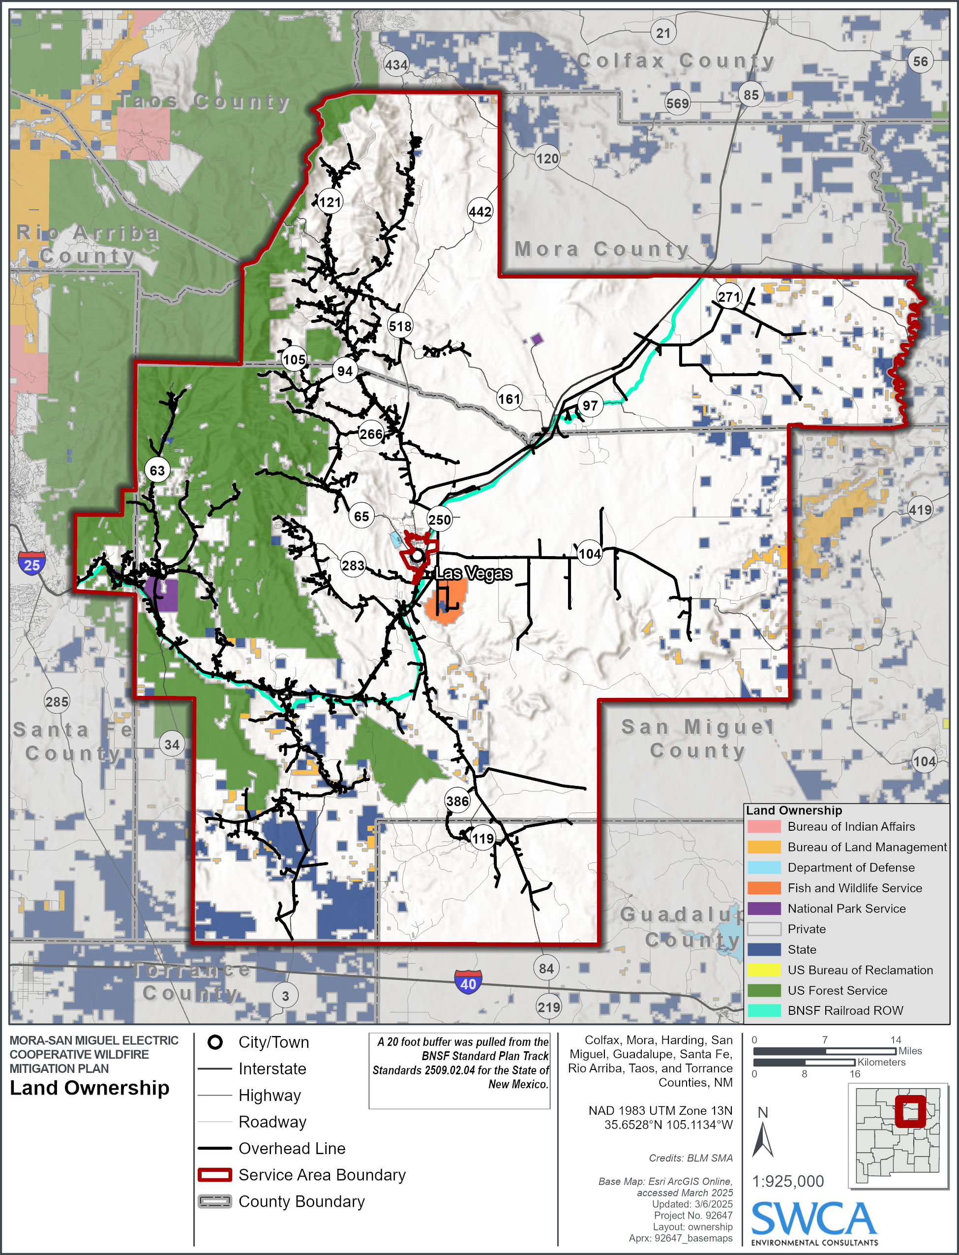

Wildfire Risk Analysis
Wildfire risk is determined through a quantitative wildfire risk framework (Figure 2) that uses recent spatial data to assess the vulnerability of assets to identify wildfire hazards. Wildfire risk is quantified using four factors:
Probability is the likelihood of a 30-square-meter pixel burning within wildfire behavior models. Probability is also characterized by the frequency and distribution of ignitions.
Intensity is an expression of the rate of energy release and is represented by flame length in feet.
Exposure is the proximity of assets to hazards on a landscape (e.g., a substation or aboveground transmission line within or above timber fuels).
Susceptibility is a measure of how easily an asset is damaged by wildfire. Factors influencing susceptibility include construction method, materials, and maintenance.
The wildfire risk products used in the WMP are sourced from the Wildfire Risk to Communities (WRC) national dataset. WRC was created by the USFS under the direction of Congress in the 2018 Consolidated Appropriations Act (H.R. 1625, Section 210). As wildfires increase in frequency and severity across the country, WRC uses the best available science to not only identify risk but to also provide resources for communities to manage and mitigate risk (USFS 2024a).
Figure 2. The Quantitative Wildfire Risk Assessment Framework.
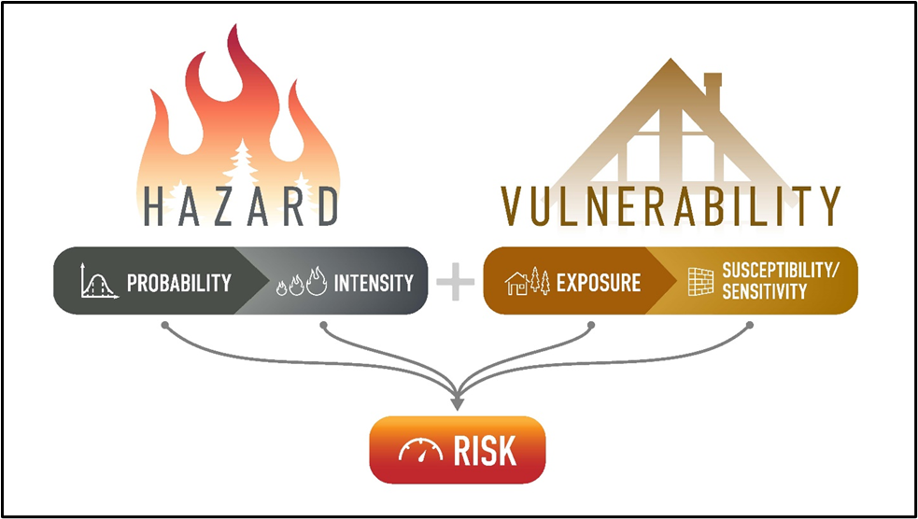
Derived from Scott et al. (2013).

Topography, Vegetation, and Climate
The MSMEC service area is topographically varied, with the Sangre De Cristo Mountains to the west and the flat high plains to the east. The landscape encompasses the transition zone between the Rocky Mountains and the Great Plains, creating unique environmental conditions and access challenges in a range of fire regimes. The region’s vegetation includes subalpine coniferous forest and montane coniferous forest at higher elevations that descend into piñon-juniper woodlands, mixed woodlands, shortgrass prairies, and riparian wetlands at lower elevations (New Mexico State University, College of Agricultural, Consumer, and Environmental Sciences 2011; State of New Mexico 2016). The climate varies slightly across the two primary topographic settings and can be characterized by data capture from National Oceanic and Atmospheric Administration (NOAA) stations in both the city of Las Vegas, New Mexico, situated at lower elevations, and the Pecos National Monument, situated in the mountains. The average annual precipitation in Las Vegas is 15.73 inches, with mean temperatures ranging from 46.7°F in January to 83.5°F in July. Pecos National Monument experiences an average of 16.17 inches of annual precipitation, with temperatures ranging from 46.6°F in January to 85.2°F in July. In both regions, most precipitation occurs from May to September, during the monsoons (NOAA 2024).

Wildfire History and Outlook
The MSMEC service area encompasses landscapes that experience significant wildfire activity, with notable peaks in certain periods (Figure 3). Wildfires burned over 13,937 acres in 1971 and over 29,461 acres in 2000 (Table 3). The most devastating year came in 2022, when extreme drought conditions, low snowpack, and high winds led to the worst wildfire season in New Mexico’s recent history. The Hermit’s Peak/Calf Canyon Fire alone burned nearly 342,000 acres and more than 900 structures, becoming the largest wildfire in the state’s history. Small communities were directly hit, and the surrounding areas, including Las Vegas, felt the significant impact of the disaster. The situation worsened when monsoon rains followed, causing massive flooding across the burn scar (Natural Resources Conservation Service n.d.)
Wildfire response and preparedness in the region is characterized by collaboration among local, state, and federal agencies. Fire response agencies in the area have robust systems in place to manage wildfire risks, with fire districts staffed by volunteer firefighters supported by the New Mexico State Forestry Division, providing essential emergency response services and capabilities such as wildland and structural fire prevention, suppression, emergency medical services, hazardous material mitigation, and rural search and rescue. The New Mexico State Forestry's Las Vegas District and the Santa Fe National Forest Pecos/Las Vegas Ranger District also provide additional fire suppression resources and support (Mora County 2019; San Miguel County 2018).
New Mexico has experienced notable shifts in temperature and precipitation patterns over the last century, contributing to increased wildfire risk. Average temperatures have risen by at least 1 degree Fahrenheit, leading to earlier snowmelt, more frequent droughts, and drier soils. These changes pose a severe threat to the state’s resources, potentially transforming rangelands into deserts and affecting agriculture, tourism, and livelihoods. The increasing frequency and severity of wildfires are closely linked to these changes in climate. More frequent and severe wildfires have been observed under these conditions, as extended dry periods and higher temperatures contribute to longer fire seasons, increased fire intensity, and the spread of forest pests. This is particularly concerning in fire-prone regions such as New Mexico’s forests and grasslands, where changing fire regimes threaten both ecosystems and human communities (Liu et al. 2010; U.S. Environmental Protection Agency 2016).
Table 3. Acres Burned in the MSMEC Service Area by Year since 1970.
Year | Acres Burned within  Service Area | Year | Acres Burned within  Service Area | Year | Acres Burned within  Service Area | Year | Acres Burned within  Service Area
1970 | 35 | 1990 | 214 | 2003 | 359 | 2016 | 304
1971 | 13,937 | 1992 | 50 | 2007 | 87 | 2017 | 2,145
1973 | 69 | 1993 | 16 | 2009 | 170 | 2018 | 130,596
1974 | 5,354 | 1994 | 238 | 2010 | 2,170 | 2019 | 2
1975 | 12 | 1995 | 304 | 2011 | 125 | 2020 | 14,708
1976 | 20 | 1997 | 97 | 2012 | 229 | 2021 | 6,567
1978 | 13 | 1998 | 21 | 2013 | 31,747 | 2022 | 683,578
1986 | 52 | 2000 | 29,461 | 2014 | 1 | 2023 | 7,195
1987 | 68 | 2001 | 166 | 2015 | 7,611 | 2024 | 29

Figure 3. Historic Wildfire Perimeters 1970–2024.
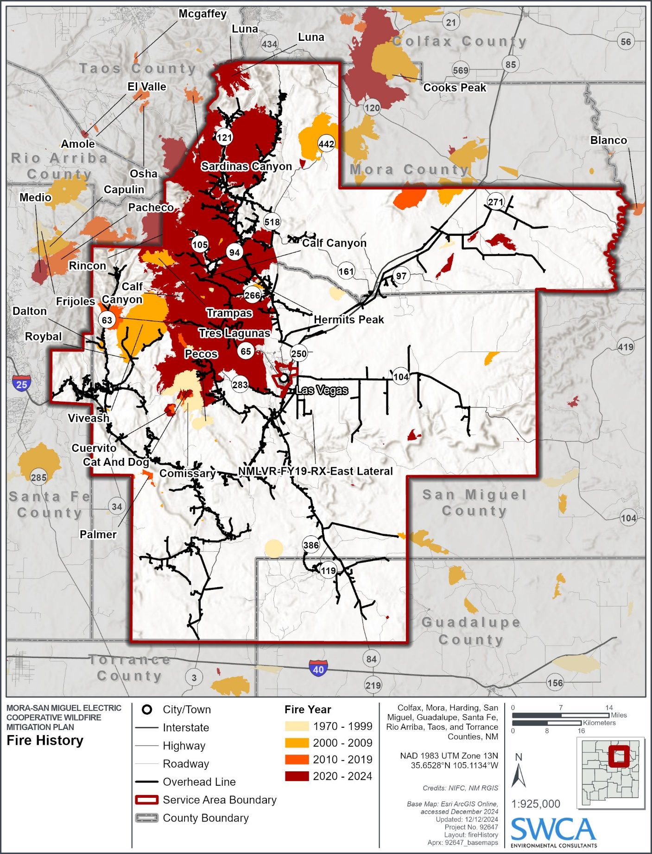

Wildfire Ignition Risk
Understanding the likelihood, frequency, and spatial distribution of wildfire ignitions is critical for determining localized wildfire risk. Examining past ignition data (Figures 4 and 5) can help identify areas of concern and the need for ignition mitigation activities (Chapter 3).
MSMEC staff evaluated other utilities’ fire causes and applied its own field experience to determine the critical potential risk drivers. The categories listed below were identified as having the potential for causing power line sparks and ignitions:
- Equipment/facility failure
- Foreign contact
- Vehicle impact
- Standard expulsion fuses
- Cross-phasing
- Legacy tree attachments
- Age of assets
- Vandalism
Within the service area, natural wildfire ignitions are most likely to occur in mountainous terrain due to lightning. These natural ignitions can occur long distances from MSMEC infrastructure, but due to the correlation of timber fuels associated with mountainous areas, these naturally ignited wildfires can quickly build in size and intensity, potentially threatening MSMEC assets located some distance from the ignition. Alternatively, human-caused ignitions are more likely to occur near roads and populated areas. These fires are often less difficult to suppress due to easier access for fire response resources. However, MSMEC assets are often found near areas where human-caused ignitions are likely. Therefore, MSMEC assets located in complex terrain containing timber fuels that are also adjacent to roads and populated areas, such as State Highway 63, are at most risk of being impacted by human wildfire ignitions. Wildfire risk is particularly high in these areas where the frequency of ignitions is also high. See Section 3.4.1, Areas of Concern, for details regarding wildfire risk for specific locations within the service area.

Weather
Severe thunderstorms and high wind events are primary drivers of wildfire ignitions and rapid fire growth. Lightning associated with fast-moving thunderstorms can ignite wildfires, and northern New Mexico experiences some of the highest frequencies of thunderstorms in the United States from June to July (Rasmussen 1971). In certain cases, vegetation ignited due to a lightning strike can smolder for weeks and even months, known as holdovers, before growing into a wildfire. High wind events can contribute to rapid fire growth of holdovers and cause ignitions by blowing down trees onto power lines. The mountains of northern New Mexico historically experience a high frequency of severe thunderstorms during the months of June and August (NOAA 2000). High wind events are commonly associated with summer thunderstorms and damaging microbursts have been observed during the spring and fall. Sustained high winds are also common from March through May when relatively strong jet stream winds mix down to the surface. Periods of high wind following thunderstorms drastically increase wildfire risk across the service area.
Figure 4. Ignition Occurrence History by Ignition Cause.
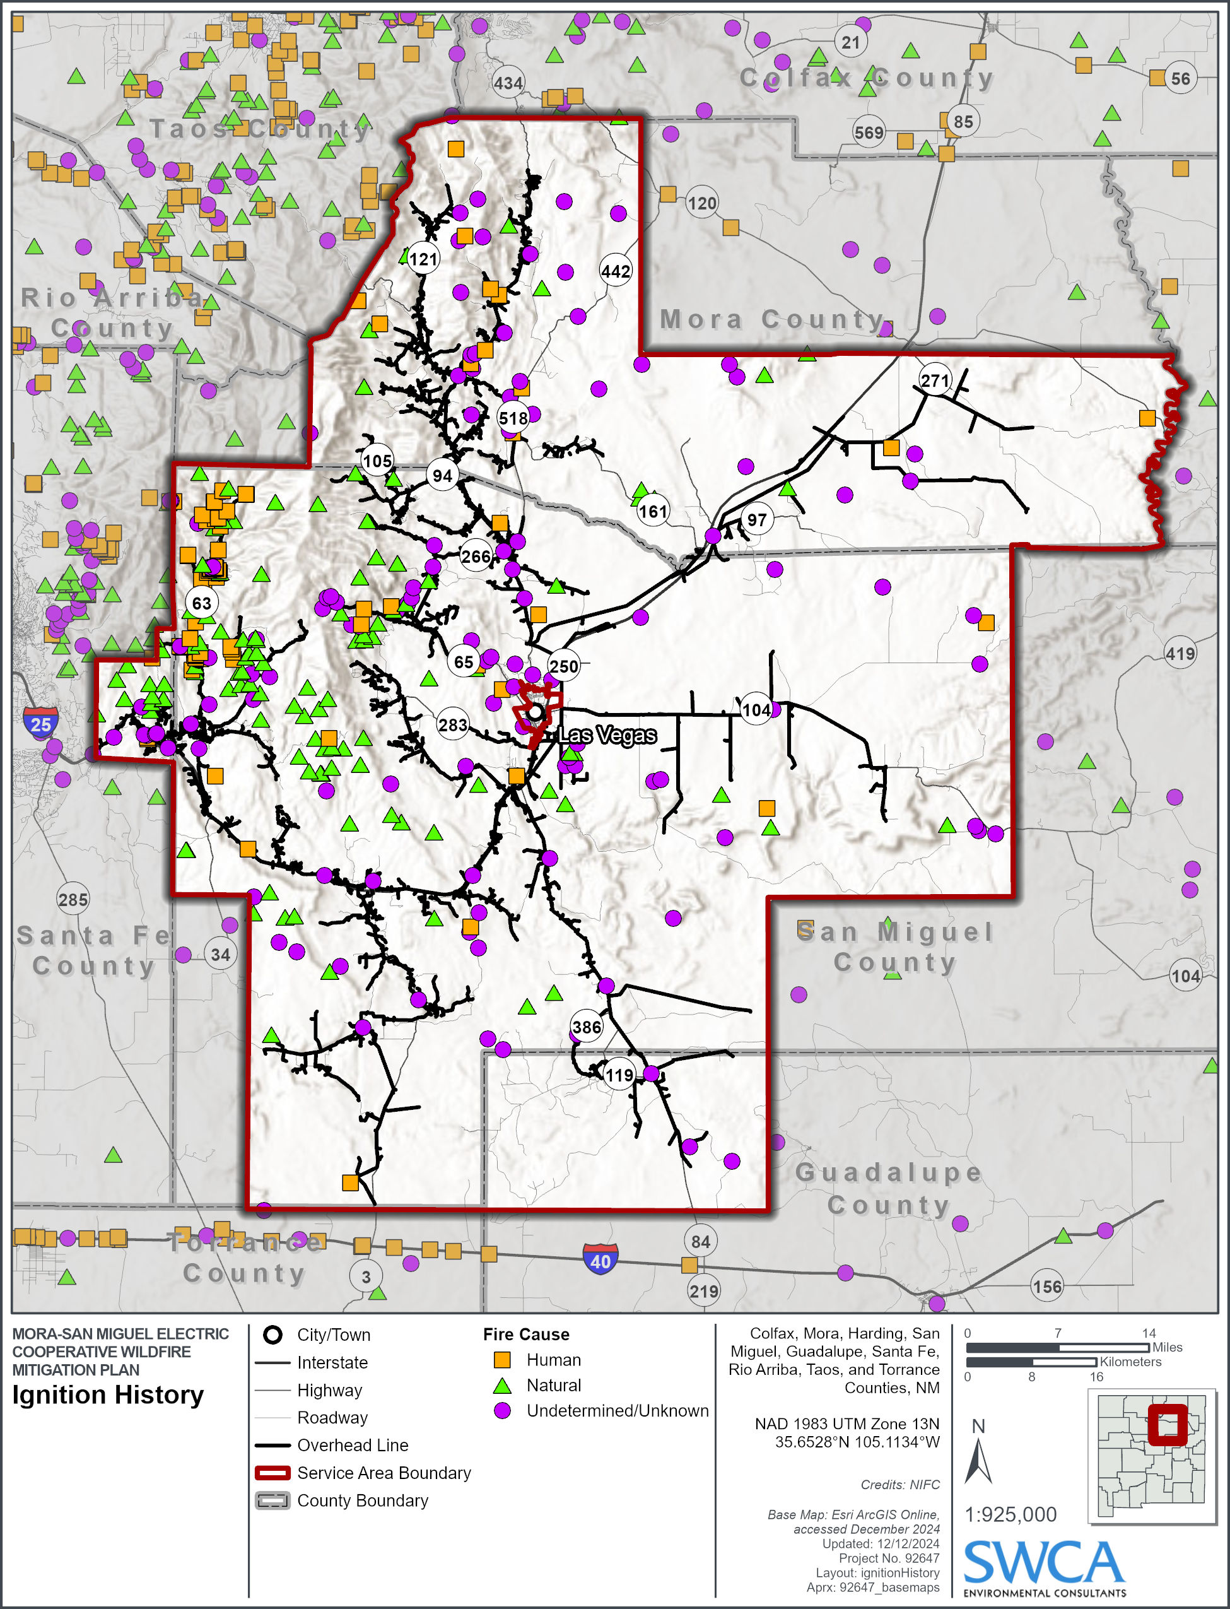
Figure 5. Density of Past Ignition Occurrences.
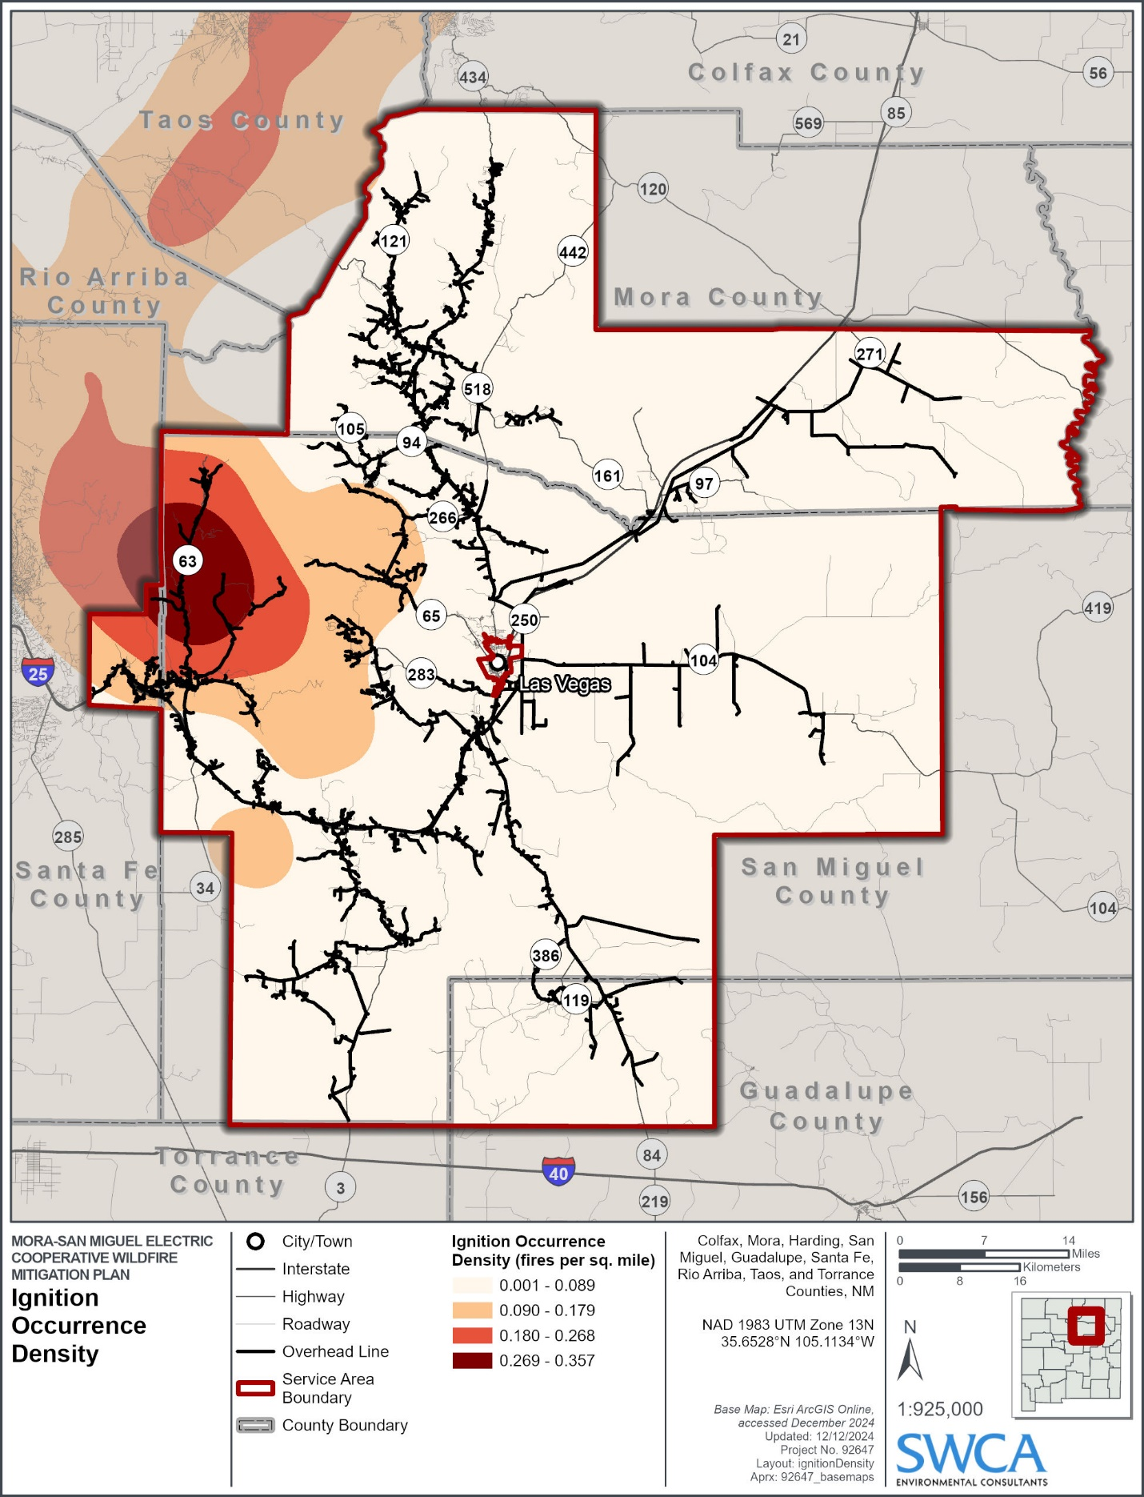

Wildfire Risk within the Service Area
Spatial wildfire risk within the service area varies greatly depending on fuels, weather, topography, and likelihood of ignitions. However, temporal wildfire risk is greatest during the months of June to August due to the high frequency of thunderstorms, wind events, and dry fuels associated with the preceding dry spring season. Spatial wildfire risk is quantified using a variety of modeled datasets. Wildfire risk (Figure 6) is determined by comparing modeled wildfire probability and intensity with generalized consequences to assets on every 30-meter pixel. Wildfire risk can be quantified across the landscape by asking the hypothetical question, “What would be the relative risk to a structure if one existed here?" regardless of whether an asset exists at that location or not. This allows comparison of wildfire risk in places where assets already exist to places where new construction may be proposed (USFS 2024b). Wildfire risk to MSMEC assets is greatest in timbered areas within the Sangre de Cristo Mountains that occur outside of the 2022 Hermit’s Peak/Calf Canyon wildfire boundaries. These areas include the corridors along State Highway 63 and State Highway 434 and the communities of Chacon, Guadalupita, Canoncito, Valencia, and East Pecos. High wildfire risk is also present in the area north of Glorieta Mesa, the area around Cerro de la Cruz, and the canyons north of Interstate 25 in the eastern part of the service area.
To further inform wildfire risk, wildfire hazard potential (WHP) (Figure 7) is quantified to determine the relative potential for wildfire that may be difficult to control. WHP integrates wildfire probability (Figure 8) and intensity (Figure 9) with additional factors including historic ignition density of small fires and the relative resistance to control posed by wildfire in different fuel types (USFS 2024b). Wildfire probability and intensity within the service area are defined and described below.
- Wildfire Probability (Figure 8): Burn probability is the annual likelihood of burning in a given location. Burn probability is greatest within the Sangre de Cristo Mountains with a notable reduction in burn probability occurring west of the State Highway 63 corridor. Burn probability is relatively high along State Highways 442, 161, 104, and 271 as well as Interstate 25 within the northeastern part of the service area.
- Wildfire Intensity (Figure 9): Conditional flame length (flame length) represents the mean headfire flame length at a given location if a fire were to occur and is a measure of average wildfire intensity. Flame length is greatest in timbered areas within the Sangre de Cristo Mountains that occur outside of the 2022 Hermit’s Peak/Calf Canyon wildfire boundaries. Flame length is also relatively high along Interstate 25 north of Glorieta Mesa. In Figure 9, symbology for flame length switches from a blue scheme to a brown scheme at the 4–6- to 6–8-foot threshold. This is done to represent the change in suppression difficulty that occurs with flame lengths greater than 8 feet, which is the maximum flame length for directly suppressing fires with mechanical means.
Additionally, MSMEC has used the WRC Community Wildfire Risk Reduction Zones dataset to identify specific exposure to, and transmission of, wildfire risk to existing assets across the service area (see Section 3.5).

Figure 6. Wildfire Risk to Potential Assets.
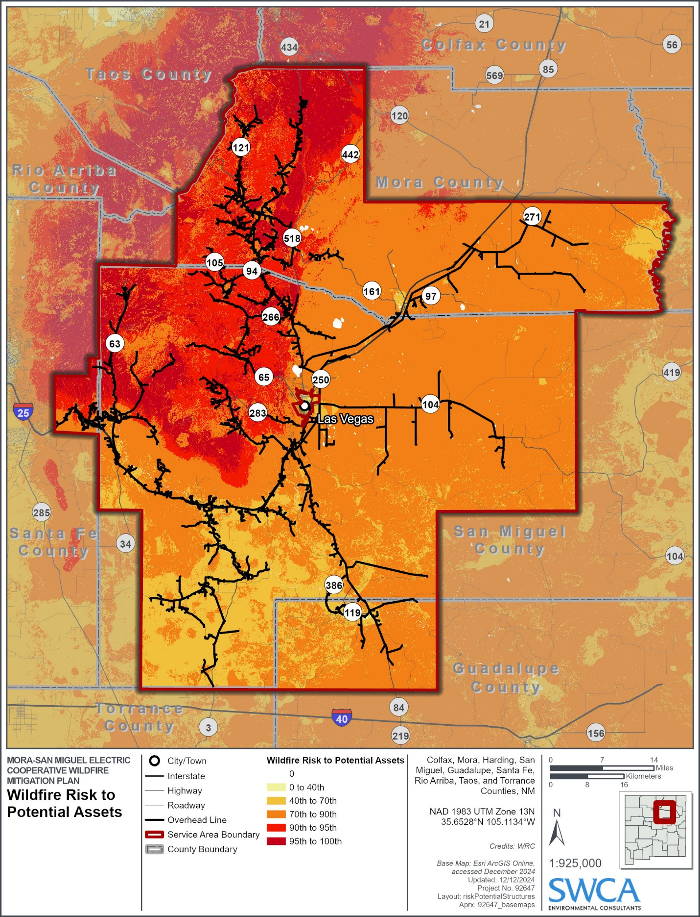
Figure 7. Wildfire Hazard Potential.
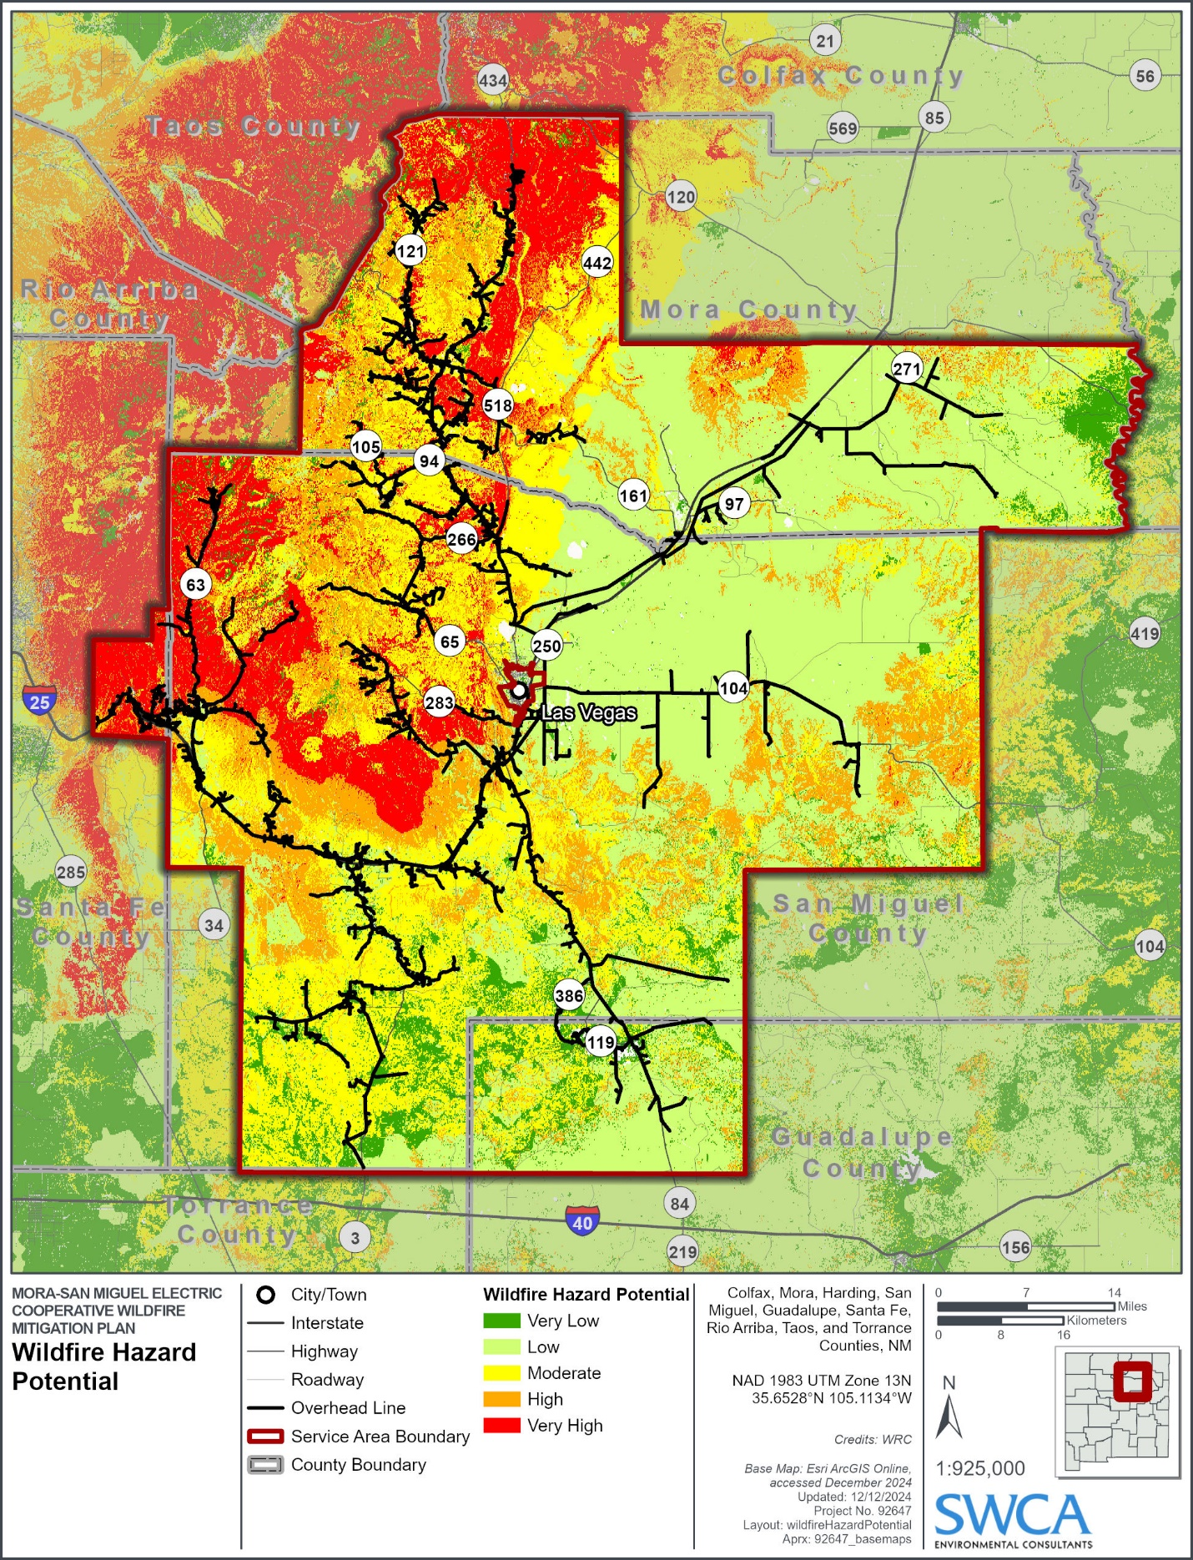
Figure 8. Wildfire Burn Probability.
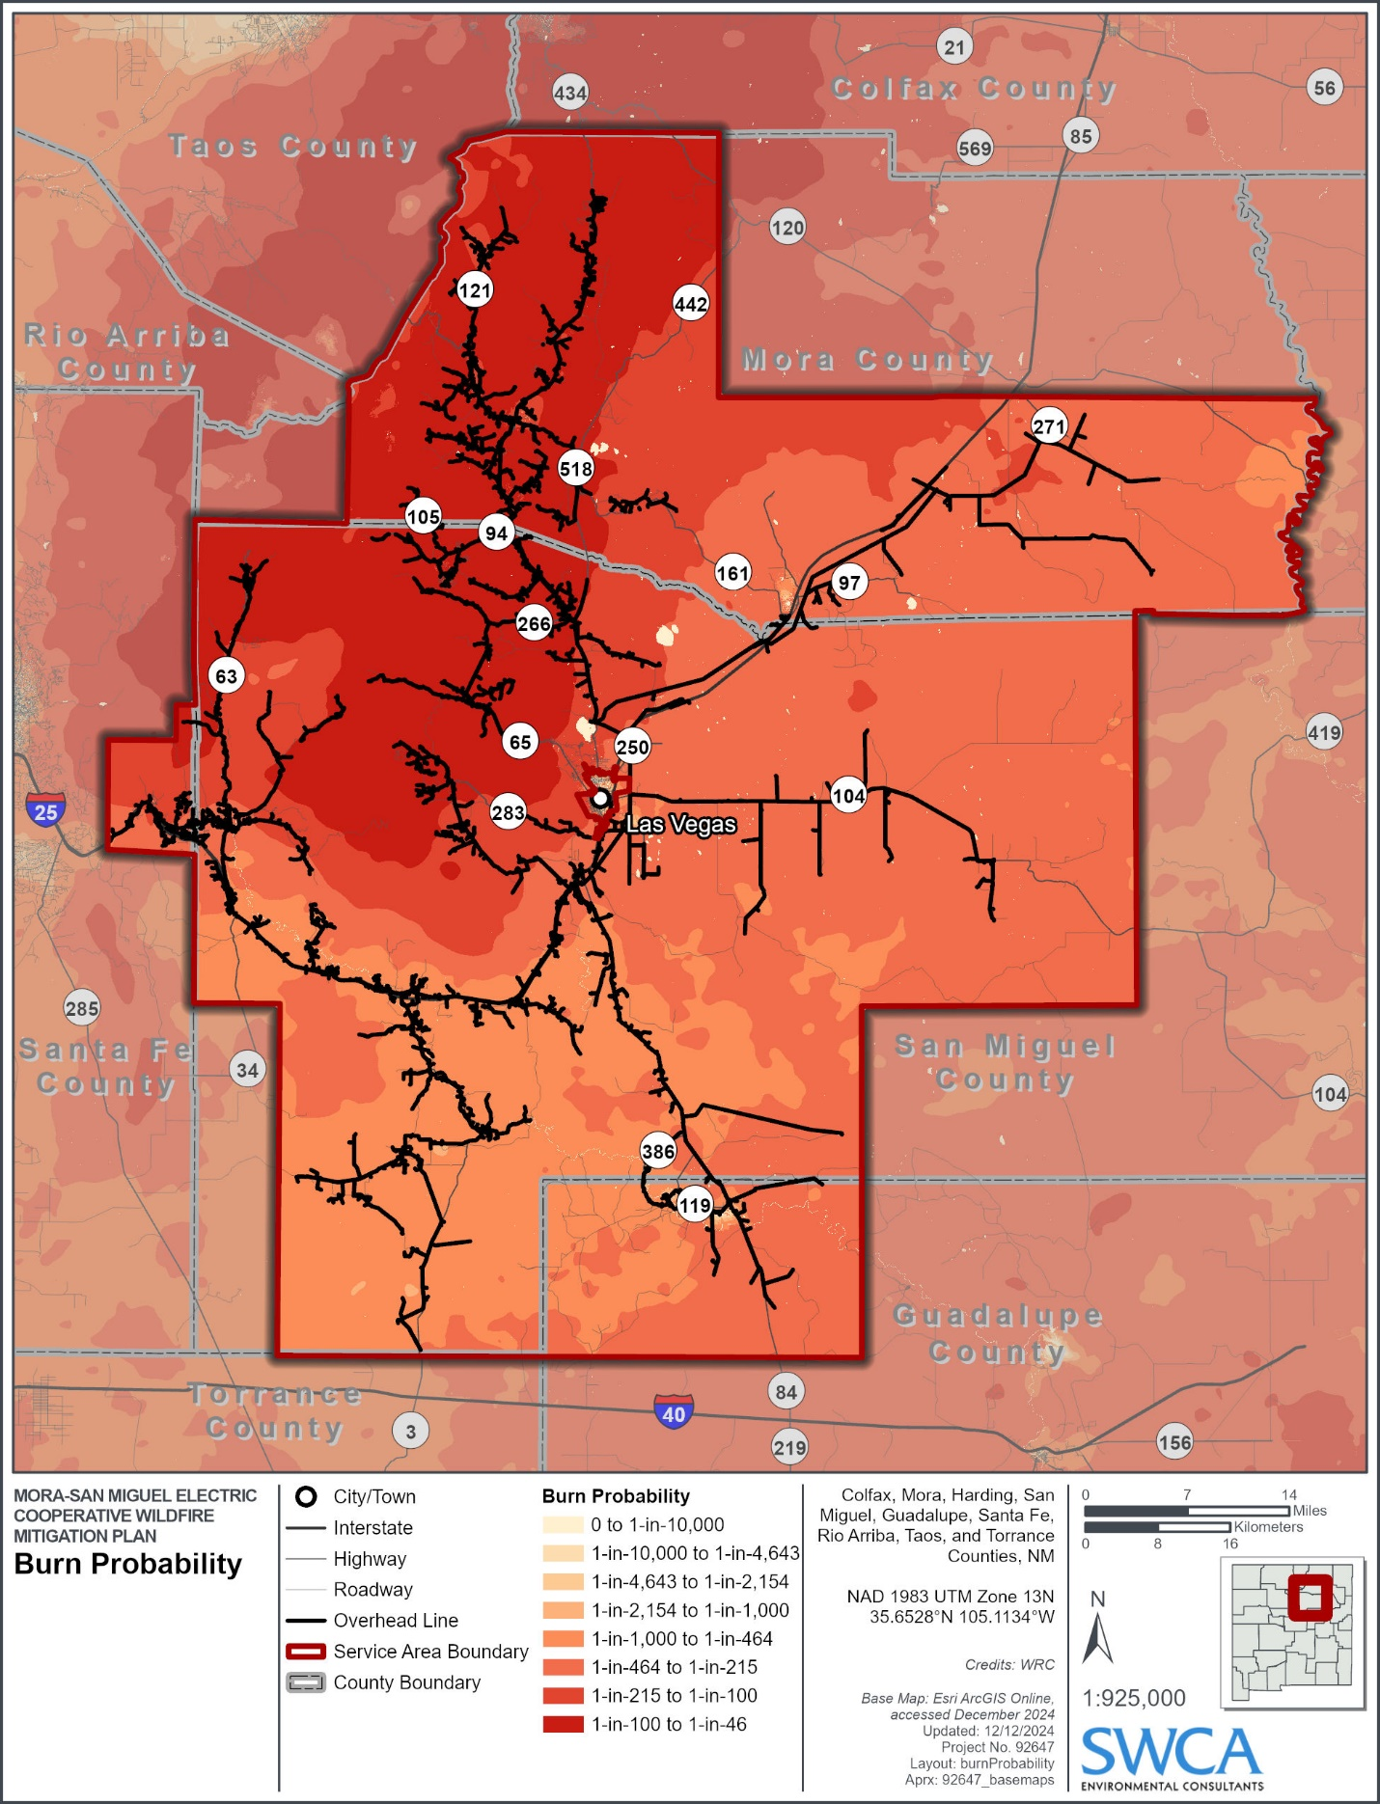
Figure 9. Wildfire Intensity (Conditional Flame Length).
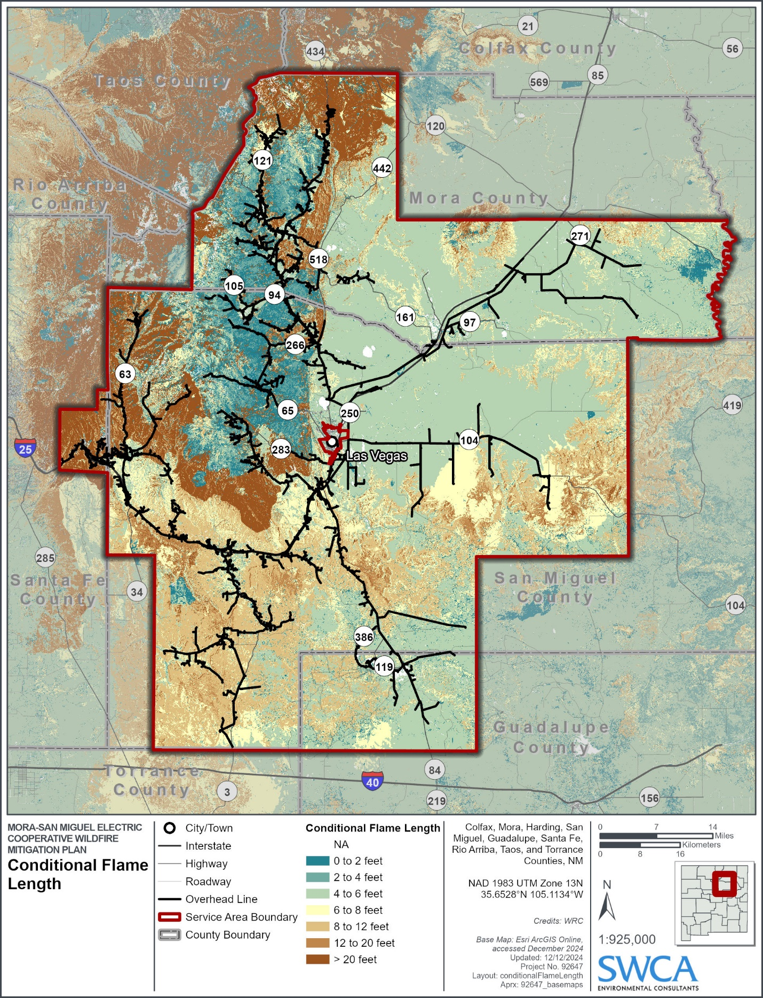

Community Wildfire Risk Reduction Zones
The Community Wildfire Risk Reduction Zones dataset (Figure 11) is a geospatial framework developed under the WRC initiative, a project mandated by the U.S. Congress in the 2018 Consolidated Appropriations Act. This initiative aims to provide national-level data to help communities understand and mitigate their wildfire risk. The Community Wildfire Risk Reduction Zones data integrate wildfire likelihood (burn probability) with proximity to populated areas, using advanced spatial analysis and buffering techniques. The zones were created by assessing wildfire exposure around building clusters, defined as areas with a minimum density of one building per 40 acres, and modeling areas where embers, radiant heat, or flames could pose risks. The framework uses inputs such as building footprints, land cover, and fire behavior data to delineate zones with varying levels of wildfire exposure and transmission potential, facilitating targeted risk-reduction strategies.
The zones are categorized as follows:
Minimal Exposure Zone: Areas unlikely to be exposed to wildfires due to their distance from flammable vegetation.
Indirect Exposure Zone: Areas near flammable vegetation but where wildfire spread is mitigated by urban or other less flammable land covers.
Direct Exposure Zone: Locations adjacent to flammable wildland vegetation, where homes are at risk from flames, radiant heat, and embers.
Wildfire Transmission Zone: Extends up to 2.4 kilometers from building clusters, representing areas that can transmit wildfire hazards via embers or spreading vegetation. This zone is further subdivided based on dominant vegetation types:
- Tree
- Shrub
- Grass
- Agriculture
- Non-Vegetated
These zones provide critical guidance for wildfire risk management by spatially prioritizing areas for specific mitigation efforts, such as creating defensible spaces, applying ignition-resistant building techniques, and conducting fuel treatments like thinning and prescribed burns. By integrating these zones into the WMP, they help MSMEC leadership allocate resources efficiently, focusing on areas where interventions can most significantly reduce wildfire impacts to communities.
Figure 11. Community Wildfire Risk Reduction Zones.
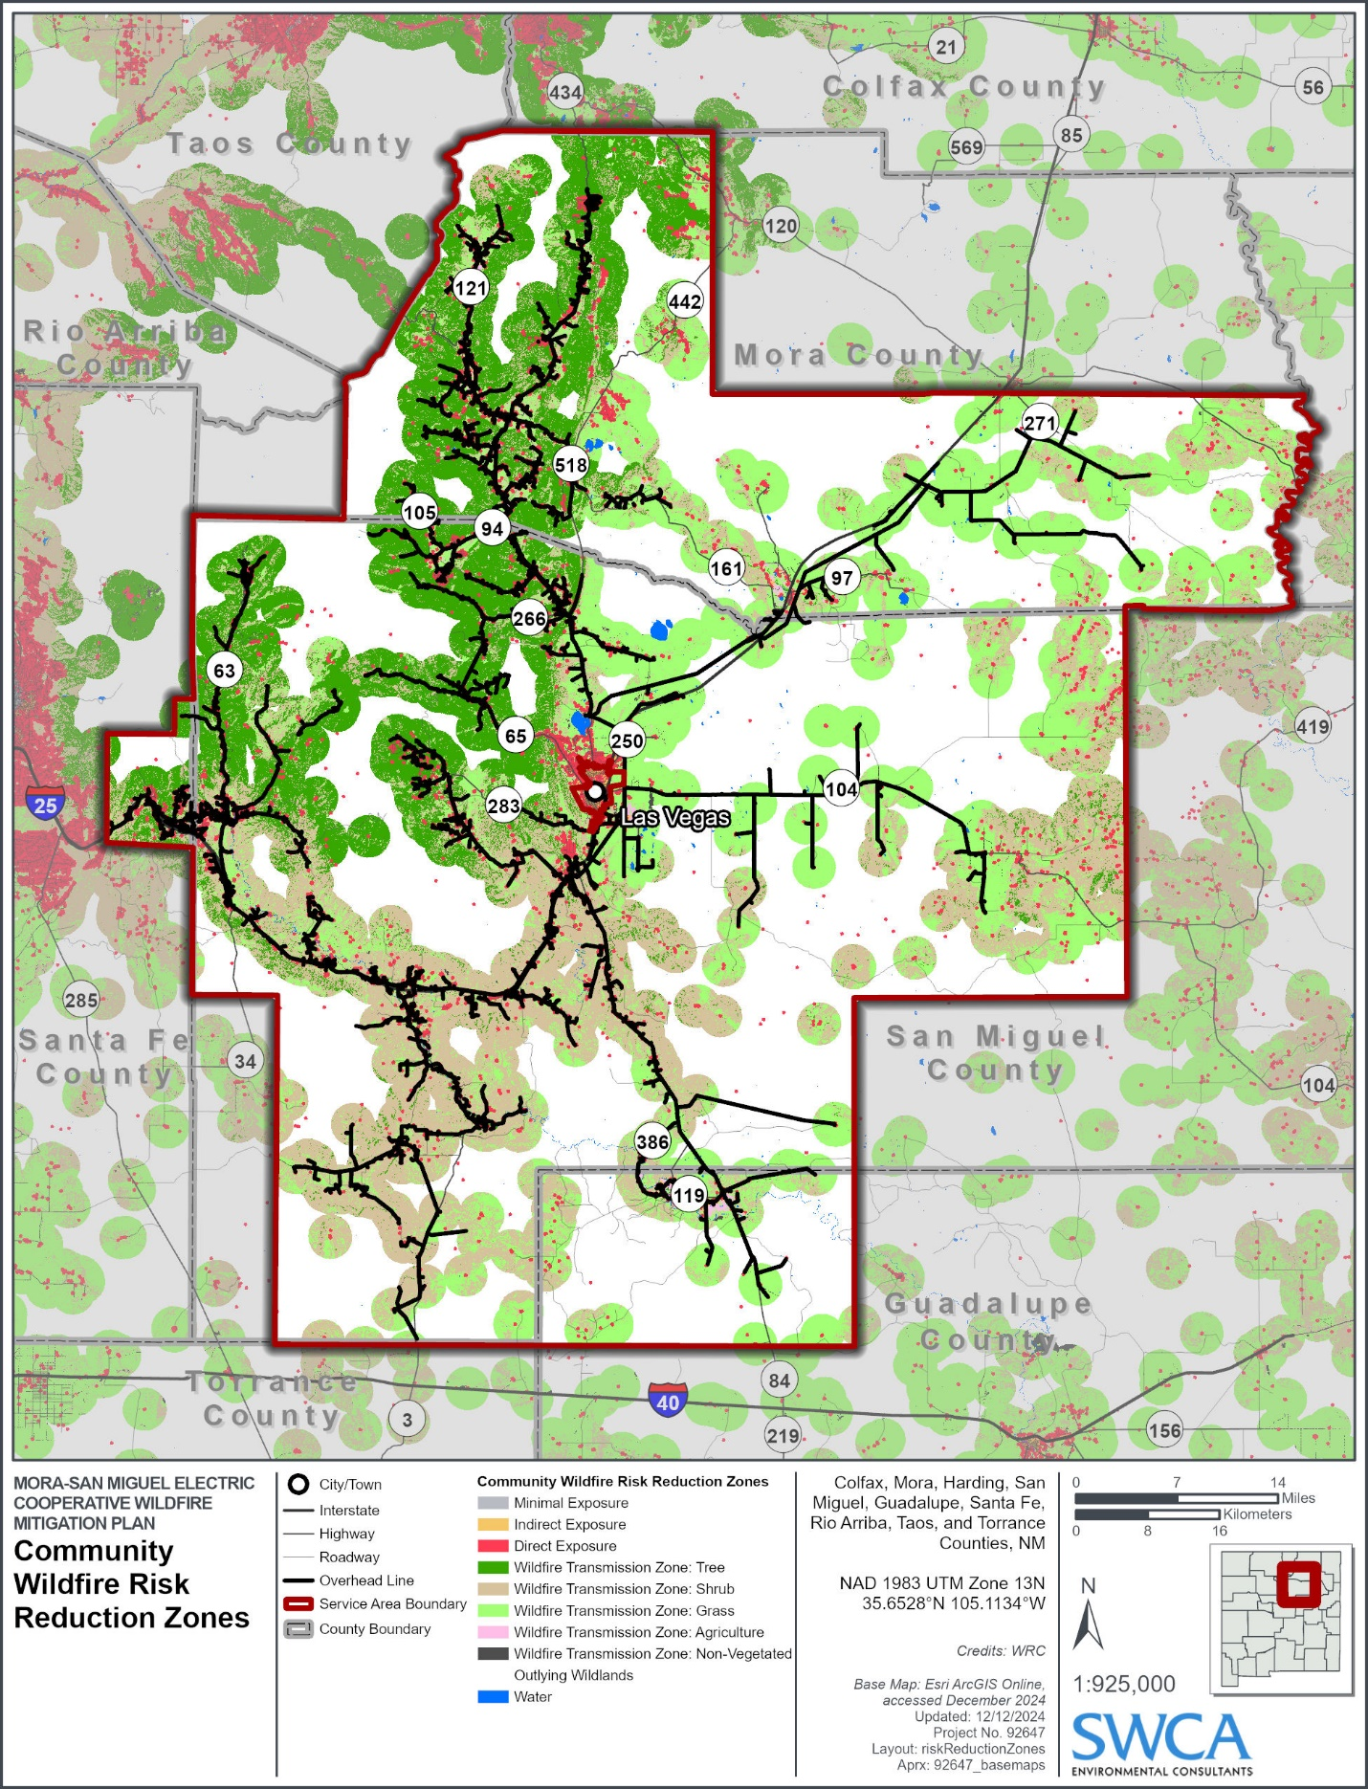

Wildfire Impacts
Wildfire impacts are directly influenced by the intensity of wildfire behavior and the susceptibility of assets to being damaged by wildfire. Wildfire impacts also include impacts to the built environment, natural resources, and human health and safety as a result of wildfire ignitions.
Wildfire in the service area can result in many outcomes. The list below outlines some of the worst-case scenarios and consequences:
- Widespread personal injuries or fatalities to the public, employees, and contractors
- Widespread damage to public and/or private property
- Widespread damage and loss of MSMEC-owned infrastructures and assets
- Widespread impacts to reliability and operations
- Damage claims and litigation costs, as well as fines from governing bodies
- Damage to MSMEC’s reputation and loss of public confidence

Wildfire Mitigation Strategy and Programs

Overview of Fire Mitigation Strategies
To minimize the risk of MSMEC assets causing wildfires, a comprehensive set of preventive strategies and programs are being implemented (Table 4). These strategies include both proactive measures currently in use and future initiatives designed to mitigate wildfire risk. MSMEC is leveraging industry best practices and new technologies to enhance grid resilience, improve vegetation management, and reduce the likelihood of ignition sources from equipment failure or external threats like extreme weather and foreign object contact. MSMEC's wildfire mitigation efforts include operational adjustments, infrastructure improvements, and enhanced inspection protocols. MSMEC is also working on adopting advanced technologies and pilot programs to further modernize its grid and improve its ability to withstand and recover from climatic and wildfire-related disruptions.
Table 4 summarizes MSMEC's five broad mitigation components with associated programs and activities that support the cooperative's ongoing commitment to wildfire prevention and mitigation.
Table 4. Mitigation Strategies/Activities.
Design and Construction |  | Description
Advanced grid hardening equipment |  | Implements durable materials and technologies to withstand extreme weather and reduce wildfire risk.
Covered jumpers and animal guards |  | Adds protective coverings to electrical components to prevent contact with wildlife and vegetation, reducing fire ignition risks.
Smart Reclosures |  | Implementing reclosures in areas of concern that can be adjusted during red-flag conditions to prevent multiple reclosing cycles after detecting a fault, which can prevent potential sparks and ignition from downed or compromised power lines.
Inspection and Maintenance |  | Description
Annual visual inspections of overhead lines |  | Conducts yearly inspections to identify and address vulnerabilities in power lines and related infrastructure.
Annual underground line inspections |  | Inspect junction boxes and transformers connected to underground lines.
Wood pole intrusive inspection and testing |  | Examines wooden utility poles for internal decay or structural weaknesses that could compromise grid stability during fire season.
Vegetation maintenance in the ROW |  | Removes hazardous vegetation along power lines to mitigate wildfire risk and ensure compliance with safety regulations.
 | Regular line patrols and detailed inspections | Conducts routine patrols to monitor the condition of transmission and distribution lines and ensure compliance with wildfire mitigation standards.
 | Removal of hazard trees within the ROW | Accelerates the removal of high-risk trees in ROWs to enhance safety and reduce fire ignition risks.
 | Enhanced vegetation management prior to fire season | Prioritizes vegetation clearing and maintenance during pre-fire season to proactively reduce wildfire risk.
 | Enhanced line patrols during fire season | Increases patrol frequency during periods of elevated fire risk to quickly identify and address hazardous conditions.
 | Operational Practices | Description
 | Contractor/staff safety training and orientation for vegetation management work | Offers orientation and ongoing training focused on safety for contractors and staff conducting vegetation management in high-risk areas.
 | Emergency communication procedures | Establishes clear, reliable communication protocols for wildfire events, ensuring efficient coordination and rapid response.
 | Fire suppression equipment on worksite during fire season | Requires fire suppression tools to be readily available on-site during fire season to promptly address any potential ignitions.
Public Safety Power Shutoff (PSPS) |  | preemptively de-energizes power lines during high wind events combined with hot and dry weather conditions.
 | Situational Awareness | Description
 | Weather monitoring in the service area | Uses advanced weather monitoring systems to assess fire risks and improve situational awareness in the utility’s service area.
 | Monitoring of critical weather and active fires in New Mexico | Tracks real-time weather patterns and active fire locations to guide operational decisions and resource deployment.
 | Response and Recovery | Description
 | Coordination with local Emergency Management and local fire departments | Works closely with local agencies and fire departments to ensure a unified and efficient response during wildfire incidents.
 | Establish memorandums of understanding (MOUs) | Establish MOUs with local fire departments and neighboring electrical Co-Ops to improve fire response times and capabilities.
 | Line patrols before re-energization | Conducts thorough inspections of de-energization lines before re-energization to ensure safety and reliability.
 | Emergency Restoration Plan | Develops and executes comprehensive restoration plans to quickly and safely restore power after wildfire-related outages.

Areas of Concern and Prioritized Action Plan
Upon completion of the quantitative wildfire risk assessment, MSMEC determined areas of concern within the service area that correspond to assets that overlap areas of high wildfire risk and hazard potential. Areas of concern are described in Table 5 and shown in Figure 10 – Figure 14 below.
Table 5. Prioritized Areas of Concern and Action Plan
Mitigation actions may be subject to change per site-specific conditions pertaining to wildfire hazards and risks as well as logistical and planning considerations.
Area of Concern ID | Wildfire Mitigation Priority | Description | Concern | Objective | Mitigation Actions | Timeline For Implementation | Funding Sources
AOC_01 | High | Located along State Highway 63 stretching from Geronimo in the north to east Pecos in the South. This includes areas with overhead lines in Holy Ghost Canyon, Macho Canyon, and Dalton Canyon. | - Poor ingress and egress for homes along the Pecos River.  - Challenging area for evacuations  - Dense timber fuels mixed with steep canyon topography increase the risk for extreme fire behavior.  - The area experiences a high frequency of natural and human-caused ignitions and has very high wildfire hazard and risk. | Prevent utility ignited wildfires. | - Upgrade utility infrastructure with sparkless fuses, smart reclosers, fault indicators, and down conductor devices.  - Clear vegetation within 30 feet of power lines along State Highway 63.  - Replace 75% of existing wooden poles with steel poles.  - Remove all hazard trees within 1.5 times the strike distance of distribution lines.  - Conduct annual UAV inspections to identify encroaching vegetation and hazard trees.  - Upgrade 25-50% of aging power lines with insulated conductors, prioritizing areas near homes.  - Place underground 25-50% of high-risk distribution lines to reduce ignition potential.  - Implement fuel reduction projects around residential areas.  - Expand defensible space around key infrastructure to 50 feet through targeted vegetation removal. | 2025 - 2027 | Grid Resilience and Innovation Partnerships (GRIP) Program  Community Wildfire Defense Grant Program (USDA Forest Service)  Hazard Mitigation Grant Program (FEMA)
AOC_02 | High | Located near overhead lines along Forest Road 86. | - Remoteness of lines presents challenges for inspection and vegetation clearance.  - The area experiences a high frequency of natural and human-caused ignitions and has very high wildfire hazard and risk. | Increase inspection coverage and frequency.  Conduct vegetation management to reduce wildfire intensity.  Prevent utility ignited wildfires. | - Implement quarterly UAV patrols to inspect infrastructure along Forest Road 86.  - Upgrade 25-50% of aging power lines with insulated conductors. Areas near homes will be prioritized.  - Remove all hazard trees within 1.5 times the strike distance of distribution lines.  - Install automated reclosers with remote capabilities.  - Increase ROW maintenance intervals from annual to semiannual in high-risk zones.  - Implement fuel reduction projects around residential areas.  - Expand defensible space around key infrastructure to 50 feet through targeted vegetation removal. | 2025 - 2027 | Joint Fire Science Program (Bureau of Land Management and U.S. Forest Service)  Smart Grid Investment Grant Program (U.S. Department of Energy)  Grid Resilience and Innovation Partnerships (GRIP) Program
AOC_04 | High | Located near overhead lines along State Highway 94, 266, and County Road A4A near the communities of Canoncito and Manuelitas. | - Numerous residential electrical service drops crossing areas of dense mature timber fuels.  - The area is designated as very high wildfire hazard and risk.  - Wildfire ignitions would threaten nearby communities. | Enhance community safety by hardening electrical infrastructure.  Prevent utility ignited wildfires. | - Place underground 25-50% of high-risk distribution lines to reduce ignition potential.  - Install non-expulsion fuses on all circuits within dense vegetation areas.  - Expand defensible space around key infrastructure to 50 feet through targeted vegetation removal.  - Upgrade poles with fire-resistant materials; replace wooden poles with steel alternatives.  - Implement fuel reduction projects around residential areas.  - Expand defensible space around key infrastructure to 50 feet through targeted vegetation removal.  - Clear vegetation within 30 feet of power lines along key highways.  - Conduct annual UAV inspections to identify encroaching vegetation and hazard trees.  - Install automated reclosers with remote capabilities. | 2025 - 2027 | Community Wildfire Defense Grant Program (USDA Forest Service)  Grid Resilience and Innovation Partnerships (GRIP) Program  Hazard Mitigation Grant Program (FEMA)
AOC_05 | High | Located near an overhead line along State Highway 518. | - High probability of entrapment if State Highway 518 is blocked.  - Overhead lines cross areas of dense mature timber fuels.  - The area is designated as very high wildfire hazard and risk. | Improve evacuation safety and reduce ignition potential.  Prevent utility ignited wildfires. | - Conduct annual UAV inspections to identify encroaching vegetation and hazard trees.  - Clear vegetation within 30 feet of power lines along key highways.  - Install automated reclosers on all major distribution circuits along Highway 518  - Implement high-impedance fault detection.  - Upgrade utility infrastructure with sparkless fuses, smart reclosers, fault indicators, and down conductor devices.  - Upgrade poles with fire-resistant materials; replace wooden poles with steel alternatives.  - Upgrade 25-50% of aging power lines with insulated conductors, prioritizing areas near homes.  - Expand defensible space around key infrastructure to 50 feet through targeted vegetation removal. | 2025 - 2027 | Grid Resilience and Innovation Partnerships (GRIP) Program  Hazard Mitigation Grant Program (FEMA)  DOE Smart Grid Investment Grants
AOC_06 | High | Located near overhead lines along State Highway 94 and the communities of Puertocito and North Carmen. | - Numerous residential electrical service drops crossing areas of dense mature timber fuels.  - The area is designated as very high wildfire hazard and risk.  - Wildfire ignitions would threaten nearby communities. | Reduce wildfire risk to residential areas by enhancing line safety.  Prevent utility ignited wildfires. | - Remove all hazard trees within 1.5 times the strike distance of distribution lines.  - Clear vegetation within 30 feet of power lines along key highways.  - Increase right-of-way (ROW) maintenance intervals from annual to semiannual in high-risk zones.  - Conduct annual UAV inspections to identify encroaching vegetation and hazard trees.  - Upgrade utility infrastructure with sparkless fuses, smart reclosers, fault indicators, and down conductor devices.  - Install non-expulsion fuses on circuits within dense vegetation areas.  - Deploy automated reclosers with remote capabilities on major distribution circuits along key highways. | 2025 - 2027 | Community Wildfire Defense Grant Program (USDA Forest Service)  Hazard Mitigation Grant Program (FEMA)  DOE Resilience Grants
AOC_08 | High | Located near overhead lines north of El Turquillo along State Highway 434, County Road A034, and the community of Guadalupita. | - Poor ingress and egress for homes along State Highway 434.  - Wildfire presents challenges for evacuation. Dense timber fuels mixed with steep canyon topography increase the risk for extreme fire behavior.  - Numerous residential electrical service drops crossing areas of dense mature timber fuels.  - The area is designated as very high wildfire hazard and risk.  - Wildfire ignitions would threaten nearby communities. | Improve evacuation safety and reduce wildfire risks.  Prevent utility ignited wildfires. | - Conduct annual UAV inspections to identify encroaching vegetation and hazard trees.  - Install automated reclosers with remote capabilities.  - Remove all hazard trees within 1.5 times the strike distance of distribution lines.  - Clear vegetation within 30 feet of power lines along key highways.  - Increase right-of-way (ROW) maintenance intervals from annual to semiannual in high-risk zones.  - Improve ROW maintenance with fire-resistant native species and targeted fire-retardant treatments.  - Establish fuel breaks and remove ladder fuels within 50 feet of critical infrastructure.  - Implement fuel reduction projects around residential areas.  - Expand defensible space around key infrastructure to 50 feet through targeted vegetation removal. | 2025 - 2027 | Grid Resilience and Innovation Partnerships (GRIP) Program  Joint Fire Science Program (BLM/USFS)  DOE Smart Grid Investment Grants
AOC_18 | High | Located along overhead lines in the Rociada and Upper Rociada residential communities, immediately north of Pendaries Village. | - Overhead lines cross regions with dense, mature timber fuels prone to crown fires.  - The area has a documented history of wildfire activity, posing recurring risks.  - Poor evacuation infrastructure in Rociada and Upper Rociada communities hampers safe egress.  - Frequent lightning strikes and human-caused ignitions contribute to elevated wildfire hazard. | Improve community resilience to wildfires through infrastructure hardening and vegetation management.  Prevent utility ignited wildfires. | - Conduct annual UAV inspections to identify encroaching vegetation and hazard trees.  - Remove all hazard trees within 1.5 times the strike distance of distribution lines.  - Clear vegetation within 30 feet of power lines along key highways.  - Increase right-of-way (ROW) maintenance intervals from annual to semiannual in high-risk zones.  - Improve ROW maintenance with fire-resistant native species and targeted fire-retardant treatments.  - Establish fuel breaks and remove ladder fuels within 50 feet of critical infrastructure.  - Place underground 25-50% of high-risk distribution lines to reduce ignition potential.  - Conduct annual pole inspections and replace compromised poles with steel alternatives. | 2025 - 2027 | Community Wildfire Defense Grant Program (USDA Forest Service)  Grid Resilience and Innovation Partnerships (GRIP) Program  Hazard Mitigation Grant Program (FEMA)
AOC_03 | Medium | Located near overhead lines northeast of Pecos along County Road B64 and Forest Road 86. | - Overhead lines cross areas of dense mature timber fuels.  - The area experiences a high frequency of natural and human-caused ignitions and has very high wildfire hazard and risk.  - Wildfire ignitions in this area may threaten the community of Pecos. | Minimize wildfire threats to Pecos by reducing overhead line vulnerabilities.  Prevent utility ignited wildfires. | - Implement UAV and LiDAR inspections every two years to track vegetation regrowth and monitor infrastructure conditions.  - Remove all hazard trees within 1.5 times the strike distance of distribution lines.  - Place underground 25-50% of high-risk distribution lines to reduce ignition potential.  - Install automated reclosers with remote capabilities. | 2027 - 2030 | Building Resilient Infrastructure and Communities (BRIC) Program (FEMA)  Grid Resilience and Innovation Partnerships (GRIP) Program  DOE Resilience Grants
AOC_07 | Medium | Located near overhead lines northwest of La Cueva along State Highway 518. | - Poor ingress and egress for homes along State Highway 518.  - Numerous residential electrical service drops crossing areas of dense mature timber fuels.  - The area is designated as very high wildfire hazard and risk.  - Wildfire ignitions would threaten nearby communities. | Address access issues and improve fire response readiness.  Prevent utility ignited wildfires. | - Implement UAV and LiDAR inspections every two years to track vegetation regrowth and monitor infrastructure conditions.  - Remove all hazard trees within 1.5 times the strike distance of distribution lines.  - Conduct annual pole inspections and replace compromised poles with steel alternatives.  - Clear vegetation within 30 feet of power lines along key highways.  - Install automated reclosers with remote capabilities. | 2027 - 2030 | Community Wildfire Defense Grant Program (USDA Forest Service)  Joint Fire Science Program (BLM/USFS)  Hazard Mitigation Grant Program (FEMA)
AOC_09 | Medium | Located near overhead lines northeast of Cleveland along San Antonio Road. | - Overhead lines cross areas of dense mature timber fuels.  - The area is designated as very high wildfire hazard and risk.  - Wildfire ignitions would threaten nearby communities. | Protect Cleveland from wildfire threats linked to overhead infrastructure.  Prevent utility ignited wildfires. | - Implement UAV and LiDAR inspections every two years to track vegetation regrowth and monitor infrastructure conditions.  - Remove all hazard trees within 1.5 times the strike distance of distribution lines.  - Place underground 25-50% of high-risk distribution lines to reduce ignition potential.  - Install automated reclosers with remote capabilities. | 2027 - 2030 | Joint Fire Science Program (BLM/USFS)  DOE Smart Grid Investment Grants  Hazard Mitigation Grant Program (FEMA)
AOC_10 | Medium | Located near overhead lines east and northeast of Chacon. | - Numerous residential electrical service drops crossing areas of dense mature timber fuels.  - The area is designated as very high wildfire hazard and risk.  - Wildfire ignitions would threaten nearby communities. | Strengthen system resilience against wildfire threats.  Prevent utility ignited wildfires. | - Implement UAV and LiDAR inspections every two years to track vegetation regrowth and monitor infrastructure conditions.  - Remove all hazard trees within 1.5 times the strike distance of distribution lines.  - Upgrade poles with fire-resistant materials; replace wooden poles with steel alternatives.  - Place underground 25-50% of high-risk distribution lines to reduce ignition potential.  - Apply fireproof coatings to the remaining wooden poles. | 2027 - 2030 | Grid Resilience and Innovation Partnerships (GRIP) Program  DOE Resilience Grants  Hazard Mitigation Grant Program (FEMA)
AOC_14 | Medium | Located near overhead lines in the residential community immediately northwest of Mineral Hill. | - Numerous residential electrical service drops crossing areas of dense mature timber fuels.  - Poor ingress and egress for remote homes in this area.  - The area experiences a high frequency of natural and human-caused ignitions and is designated as very high wildfire hazard and risk.  - Wildfire ignitions would threaten many nearby communities. | Prevent utility ignited wildfires. | - Implement UAV and LiDAR inspections every two years to track vegetation regrowth and monitor infrastructure conditions.  - Remove all hazard trees within 1.5 times the strike distance of distribution lines.  - Conduct annual pole inspections and replace compromised poles with steel alternatives. | 2027 - 2030 | Grid Resilience and Innovation Partnerships (GRIP) Program  DOE Smart Grid Investment Grants  Hazard Mitigation Grant Program (FEMA)
AOC_15 | Medium | Located near the Oja Felize community along Highway 442 | - Numerous homes near hazardous vegetation  - High wildfire hazard and risk. | Prevent damage to homes. | - Work with homeowners and local fire response agencies to mitigate wildfire hazards. | 2027 - 2030 | Community Wildfire Defense Grant Program (USDA Forest Service)  Hazard Mitigation Grant Program (FEMA)  Joint Fire Science Program (BLM/USFS)
AOC_17 | Medium | Located along overhead lines in the residential community immediately west of Gallinas. | - Dense timber fuels and steep canyon topography create conditions for extreme fire behavior.  - Limited road access restricts emergency response capabilities in wildfire situations.  - Historical ignition points in the region increase the likelihood of future wildfires.  - High wind corridors funnel through the area, intensifying fire spread potential. | Minimize wildfire threats by mitigating dense fuels and enhancing emergency access.  Prevent utility ignited wildfires. | - Implement UAV and LiDAR inspections every two years to track vegetation regrowth and monitor infrastructure conditions.  - Remove all hazard trees within 1.5 times the strike distance of distribution lines.  - Place underground 25-50% of high-risk distribution lines to reduce ignition potential.  - Install automated reclosers with remote capabilities. | 2027 - 2030 | Community Wildfire Defense Grant Program (USDA Forest Service)  Grid Resilience and Innovation Partnerships (GRIP) Program  Hazard Mitigation Grant Program (FEMA)
AOC_19 | Medium | Located along overhead lines near the Watrous and Valmora residential communities | - Numerous residential service drops are surrounded by dense vegetation, increasing ignition risk.  - Poor road conditions and single-access routes limit safe evacuation during fires.  - The area’s rugged terrain complicates firefighting efforts and emergency response times.  - Strong seasonal winds can rapidly escalate small ignitions into large-scale wildfires. | Reduce wildfire hazards near Watrous and Valmora by addressing vegetation and access.  Prevent utility ignited wildfires. | - Implement UAV and LiDAR inspections every two years to track vegetation regrowth and monitor infrastructure conditions.  - Remove all hazard trees within 1.5 times the strike distance of distribution lines.  - Implement fuel reduction projects around residential areas.  - Expand defensible space around key infrastructure to 50 feet through targeted vegetation removal. | 2027 - 2030 | Hazard Mitigation Grant Program (FEMA)  Emergency Relief Program (U.S. Department of Transportation)  DOE Resilience Grants
AOC_11 | Low | Located near overhead lines west of Pecos along Interstate 25 and the communities of La Cueva and Valencia. | - Numerous residential electrical service drops crossing areas of dense mature timber fuels.  - The area experiences a high frequency of natural and human-caused ignitions and is designated as very high wildfire hazard and risk.  - Wildfire ignitions would threaten many nearby communities. | Prevent utility ignited wildfires. | - Implement UAV and LiDAR inspections every three years to track vegetation regrowth and monitor infrastructure conditions.  - Remove all hazard trees within 1.5 times the strike distance of distribution lines.  - Clear vegetation within 30 feet of power lines along key highways. | 2030 - 2035 | Joint Fire Science Program (Bureau of Land Management and U.S. Forest Service)  Community Wildfire Defense Grant Program (USDA Forest Service)  Hazard Mitigation Grant Program (FEMA)
AOC_12 | Low | Located near overhead lines east of Pecos along County Roads B44 and B60. | - Poor ingress and egress for homes along county roads.  - Numerous residential electrical service drops crossing areas of dense mature timber fuels.  - The area is designated as very high wildfire hazard and risk. | Enhance safety by reducing fuel loads and improving access.  Prevent utility ignited wildfires. | - Implement UAV and LiDAR inspections every three years to track vegetation regrowth and monitor infrastructure conditions.  - Remove all hazard trees within 1.5 times the strike distance of distribution lines. | 2030 - 2035 | Hazard Mitigation Grant Program (FEMA)  Community Wildfire Defense Grant Program (USDA Forest Service)  Emergency Relief Program (U.S. Department of Transportation)
AOC_13 | Low | Located near overhead lines along Interstate 25 near the communities of Gise and Ilfeld. | - High winds in the area paired with moderate to high modeled flame lengths.  - The area is designated as moderate to high wildfire and risk.  - Wildfire ignitions could spread rapidly in grass/brush fuels and threaten many nearby communities. | Mitigate wind-related wildfire risks.  Prevent utility ignited wildfires. | - Implement UAV and LiDAR inspections every three years to track vegetation regrowth and monitor infrastructure conditions.  - Remove all hazard trees within 1.5 times the strike distance of distribution lines.  - Enhance real-time weather monitoring systems and install new weather monitoring stations.  - Clear vegetation within 30 feet of power lines along key highways. | 2030 - 2035 | Grid Resilience and Innovation Partnerships (GRIP) Program  DOE Resilience Grants  Hazard Mitigation Grant Program (FEMA)
AOC_16 | Low | Located along overhead lines in the residential community Gallinas, northwest of Trout Spring. | - Limited ingress and egress routes increase evacuation challenges during wildfire events.  - Steep slopes combined with dense forest fuels heighten the risk of rapid fire spread.  - The area experiences frequent wind events, which can exacerbate fire behavior.  - Proximity to residential areas raises concerns for community safety and property loss. | Reduce wildfire ignition risk by enhancing line safety and improving evacuation routes. | - Implement UAV and LiDAR inspections every three years to track vegetation regrowth and monitor infrastructure conditions.  - Remove all hazard trees within 1.5 times the strike distance of distribution lines.  - Upgrade 25-50% of aging power lines with insulated conductors, prioritizing areas near homes. | 2030 - 2035 | Joint Fire Science Program (BLM/USFS)  DOE Smart Grid Investment Grants  Community Wildfire Defense Grant Program (USDA Forest Service)
AOC_20 | Low | Located along overhead lines near the residential communities east of Dilia. | - High wind exposure combined with moderate to high fuel loads raises wildfire ignition potential.  - Limited emergency access roads and poor egress routes create evacuation bottlenecks.  - Overhead lines are vulnerable to falling trees and wind-driven debris during storms.  - Nearby communities face heightened risk due to dense residential development near wildland areas. | Mitigate wind-related wildfire risks and improve community safety through infrastructure | - Implement UAV and LiDAR inspections every three years to track vegetation regrowth and monitor infrastructure conditions.  - Remove all hazard trees within 1.5 times the strike distance of distribution lines.  - Enhance real-time weather monitoring systems and install new weather monitoring stations. | 2030 - 2035 | Grid Resilience and Innovation Partnerships (GRIP) Program  DOE Resilience Grants  Hazard Mitigation Grant Program (FEMA)
AOC_21 | Low | Located along overhead lines near residential communities Garanbuio, Lovato, Villanueva, and El Cerrito | - Numerous residential service drops are surrounded by dense vegetation, increasing ignition risk.  - Wildfire ignitions would threaten many nearby communities.  - The area has a documented history of wildfire activity, posing recurring risks. | Mitigate wildfire-related ignition risks from electrical infrastructure | - Implement UAV and LiDAR inspections every three years to track vegetation regrowth and monitor infrastructure conditions.  - Remove all hazard trees within 1.5 times the strike distance of distribution lines.  - Implement fuel reduction projects around residential areas.  - Expand defensible space around key infrastructure to 50 feet through targeted vegetation removal. | 2030 - 2035 | Community Wildfire Defense Grant Program (USDA Forest Service)  Grid Resilience and Innovation Partnerships (GRIP) Program  Hazard Mitigation Grant Program (FEMA)

Areas of Concern Maps
Upon completion of the quantitative wildfire risk assessment, MSMEC determined areas of concern within the service area that correspond to assets that overlap areas of high wildfire risk and hazard potential. Areas of concern are shown in Figure 10 through Figure and described in Table 5 below.
Figure 10. MSMEC Areas of Concern.
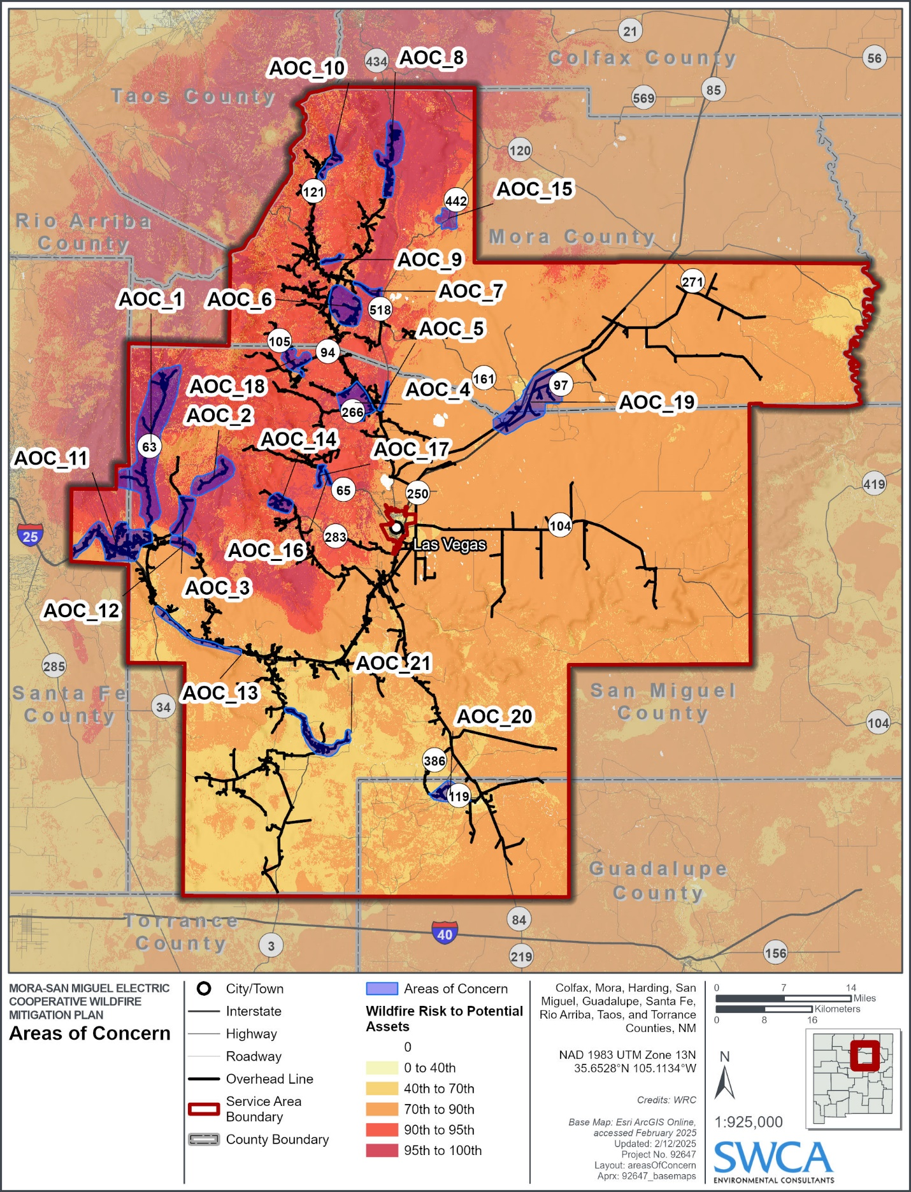
Figure 11. MSMEC areas of concern in the northwest portion of the MSMEC service area.
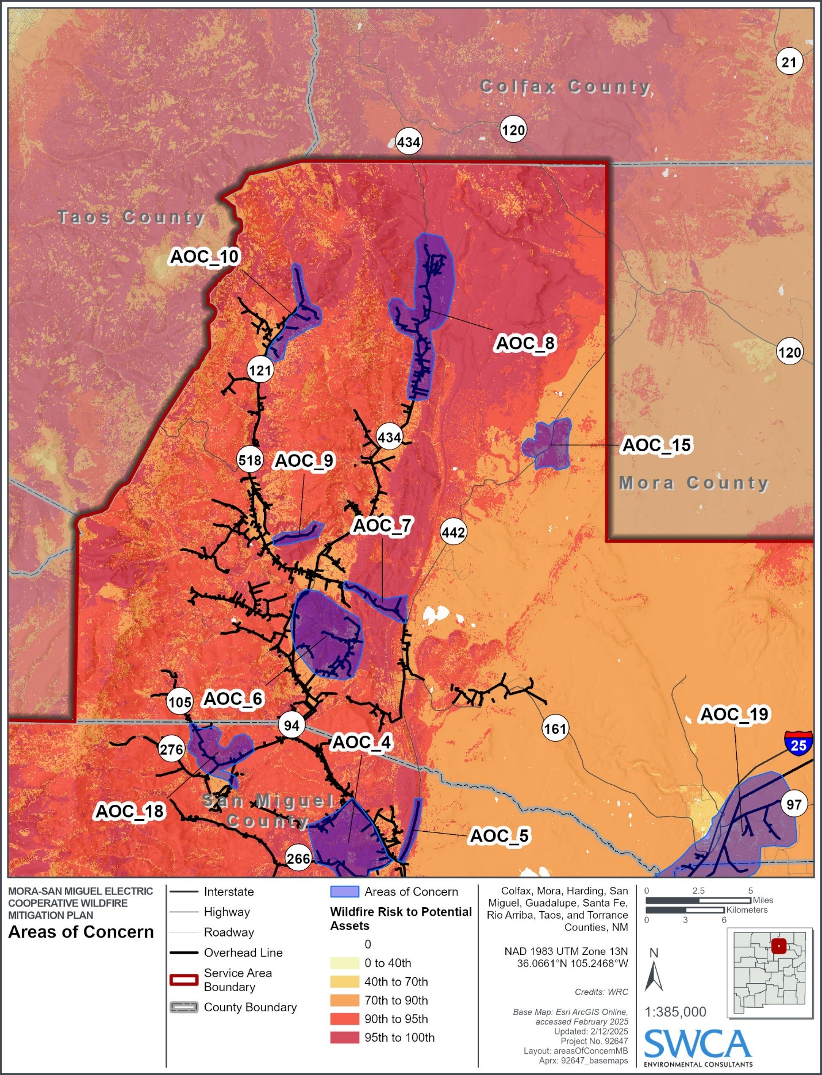
Figure 12. MSMEC areas of concern in the northeast portion of the MSMEC service area.
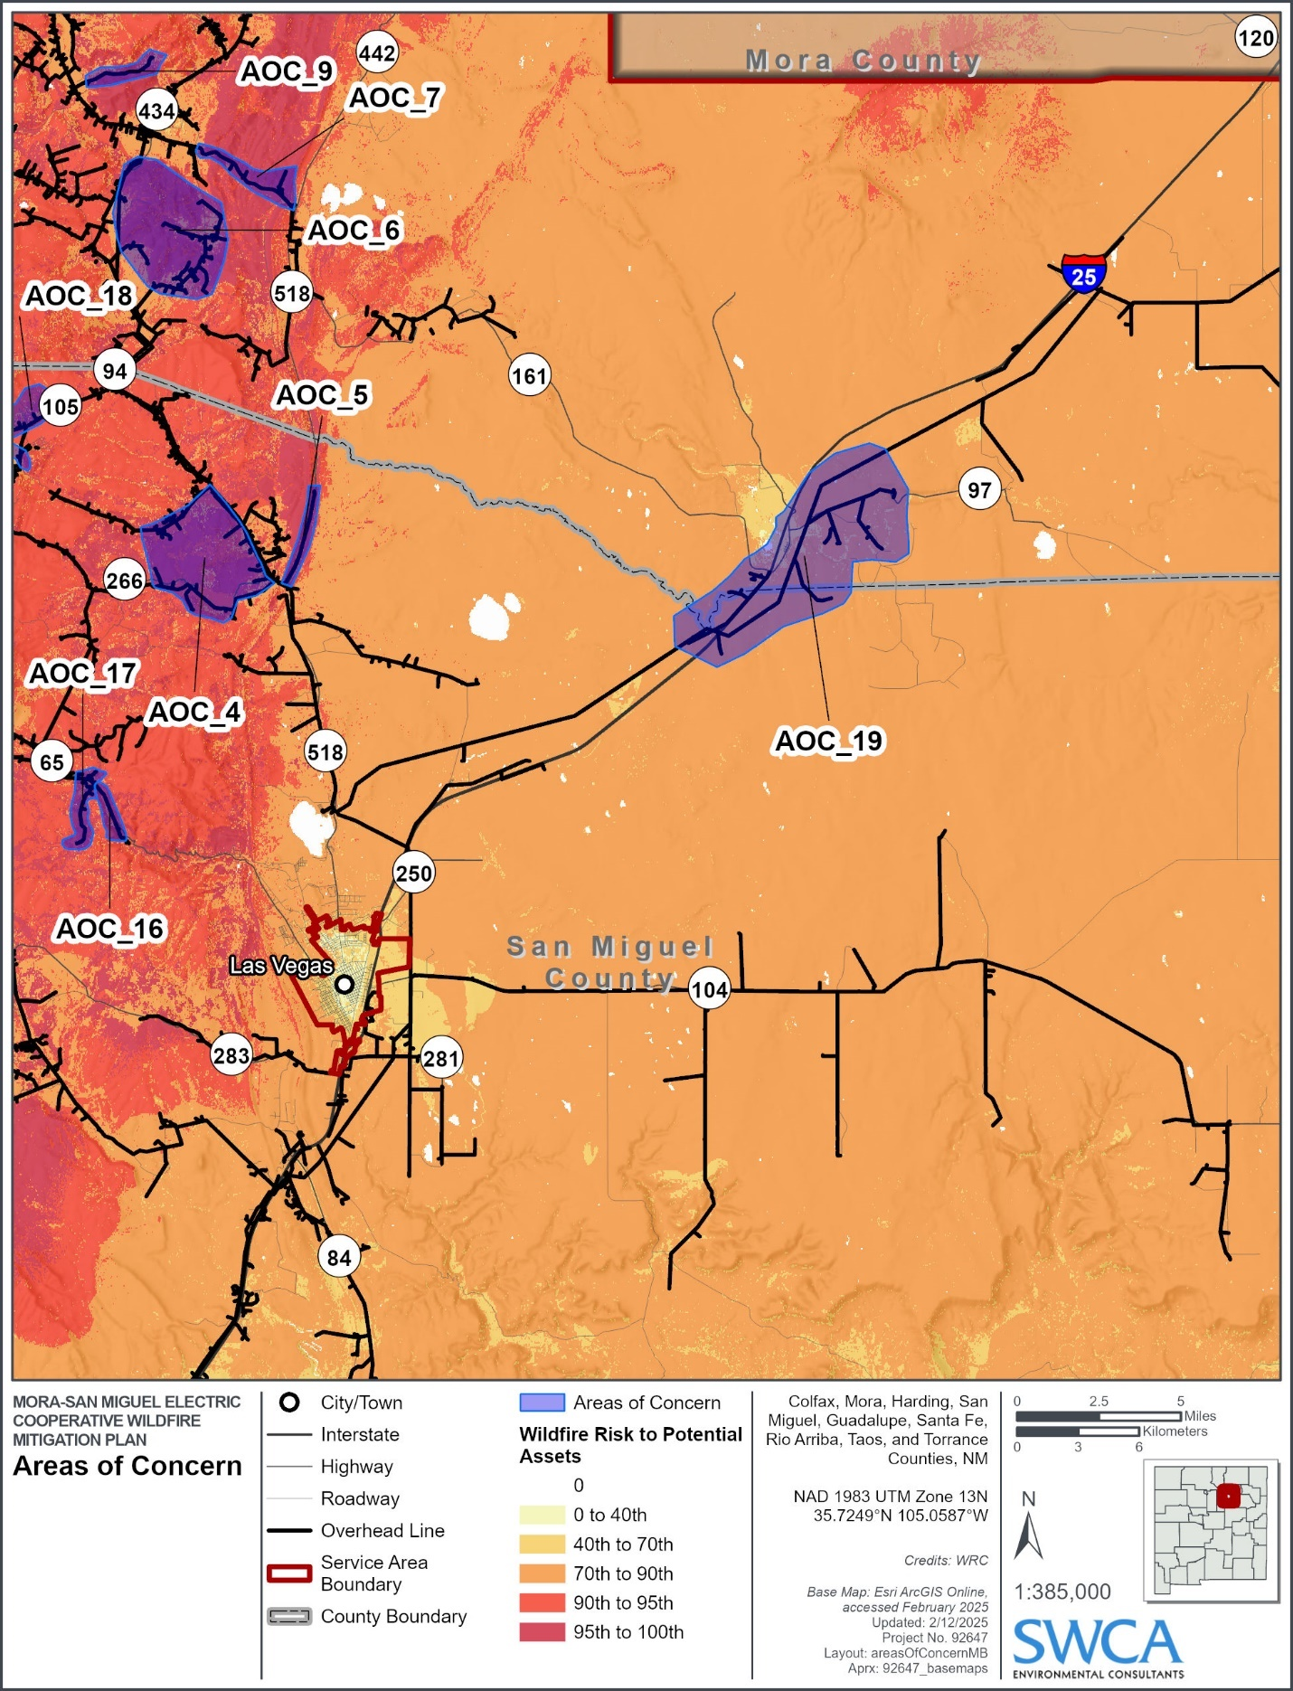
Figure 13. MSMEC areas of concern in the southwest portion of the MSMEC service area.
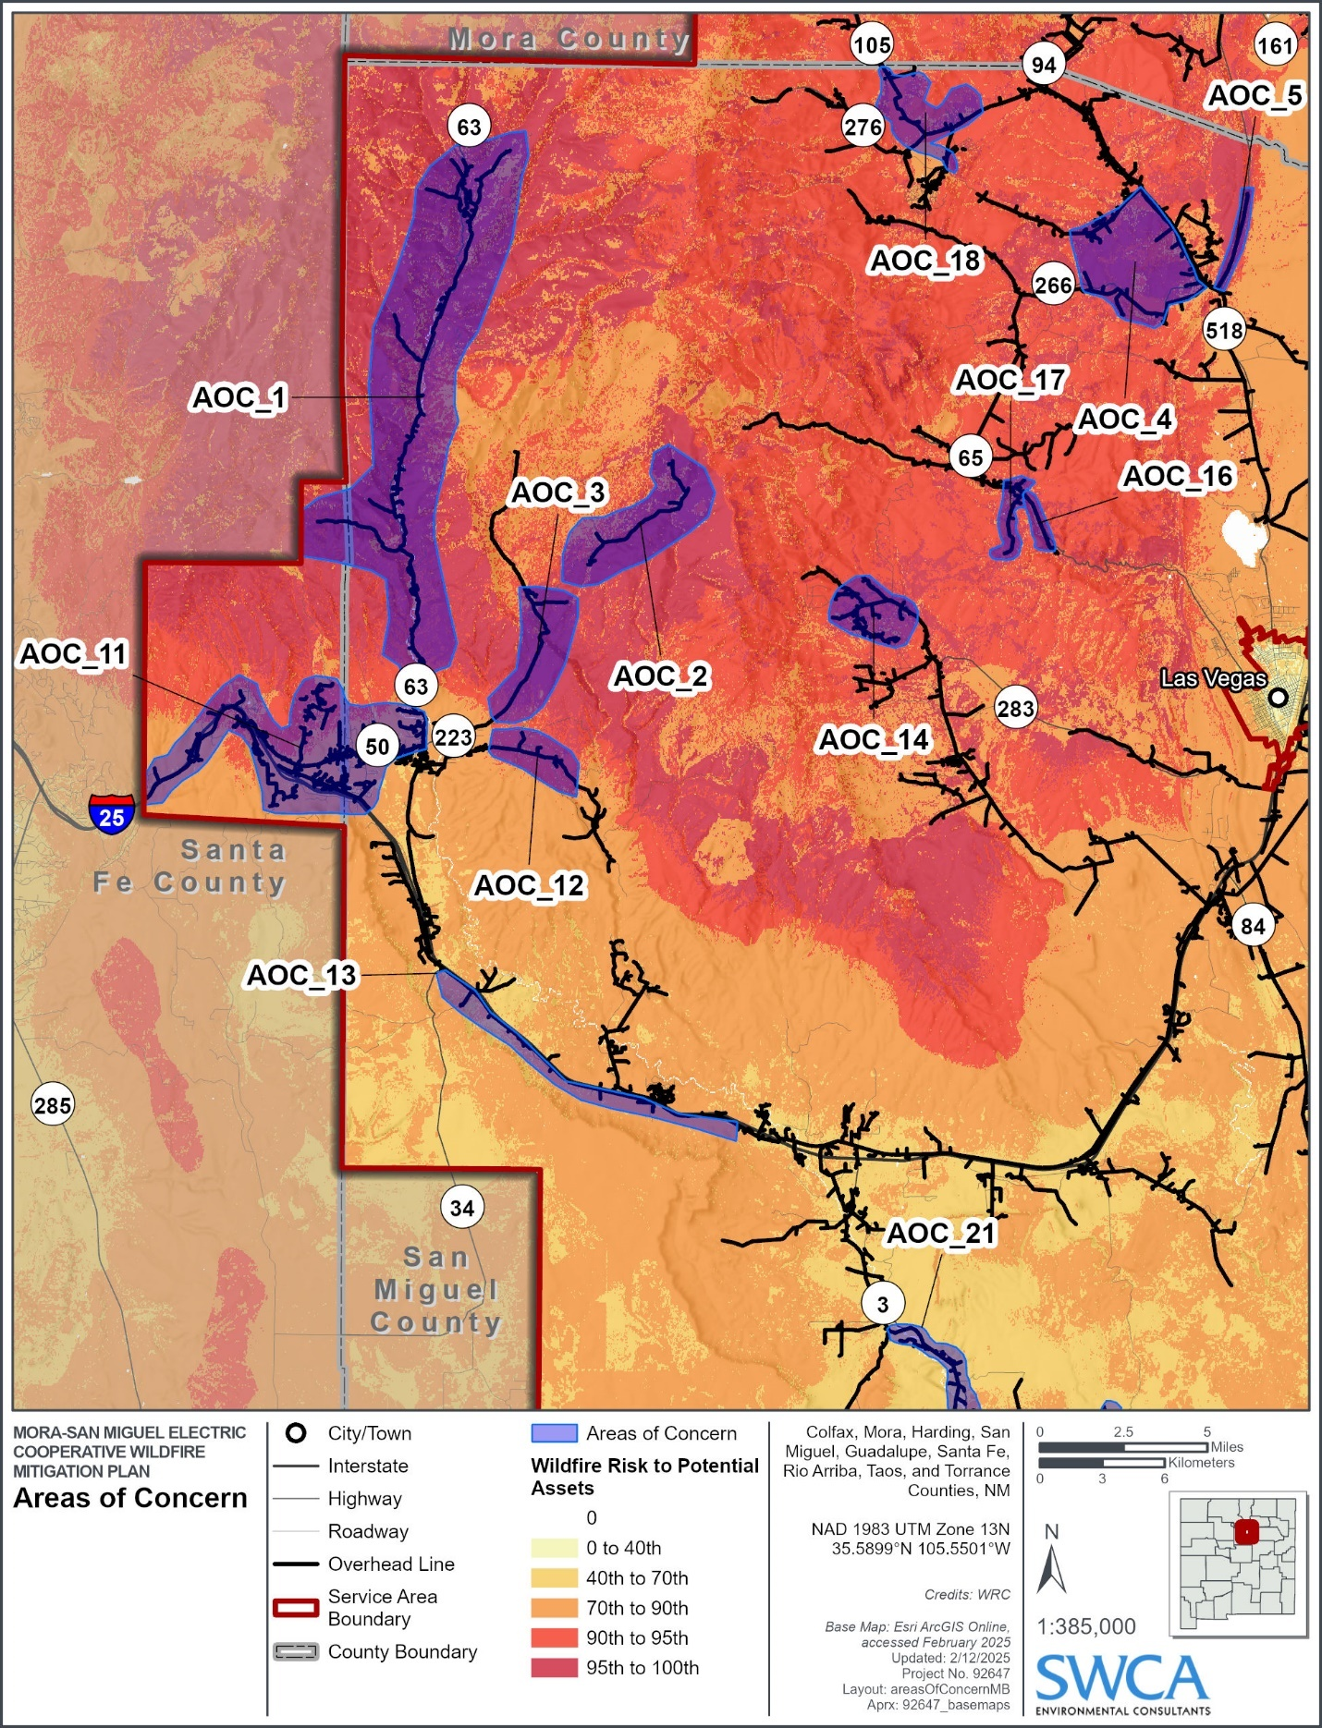

Figure 14. MSMEC areas of concern in the southeast portion of the MSMEC service area.
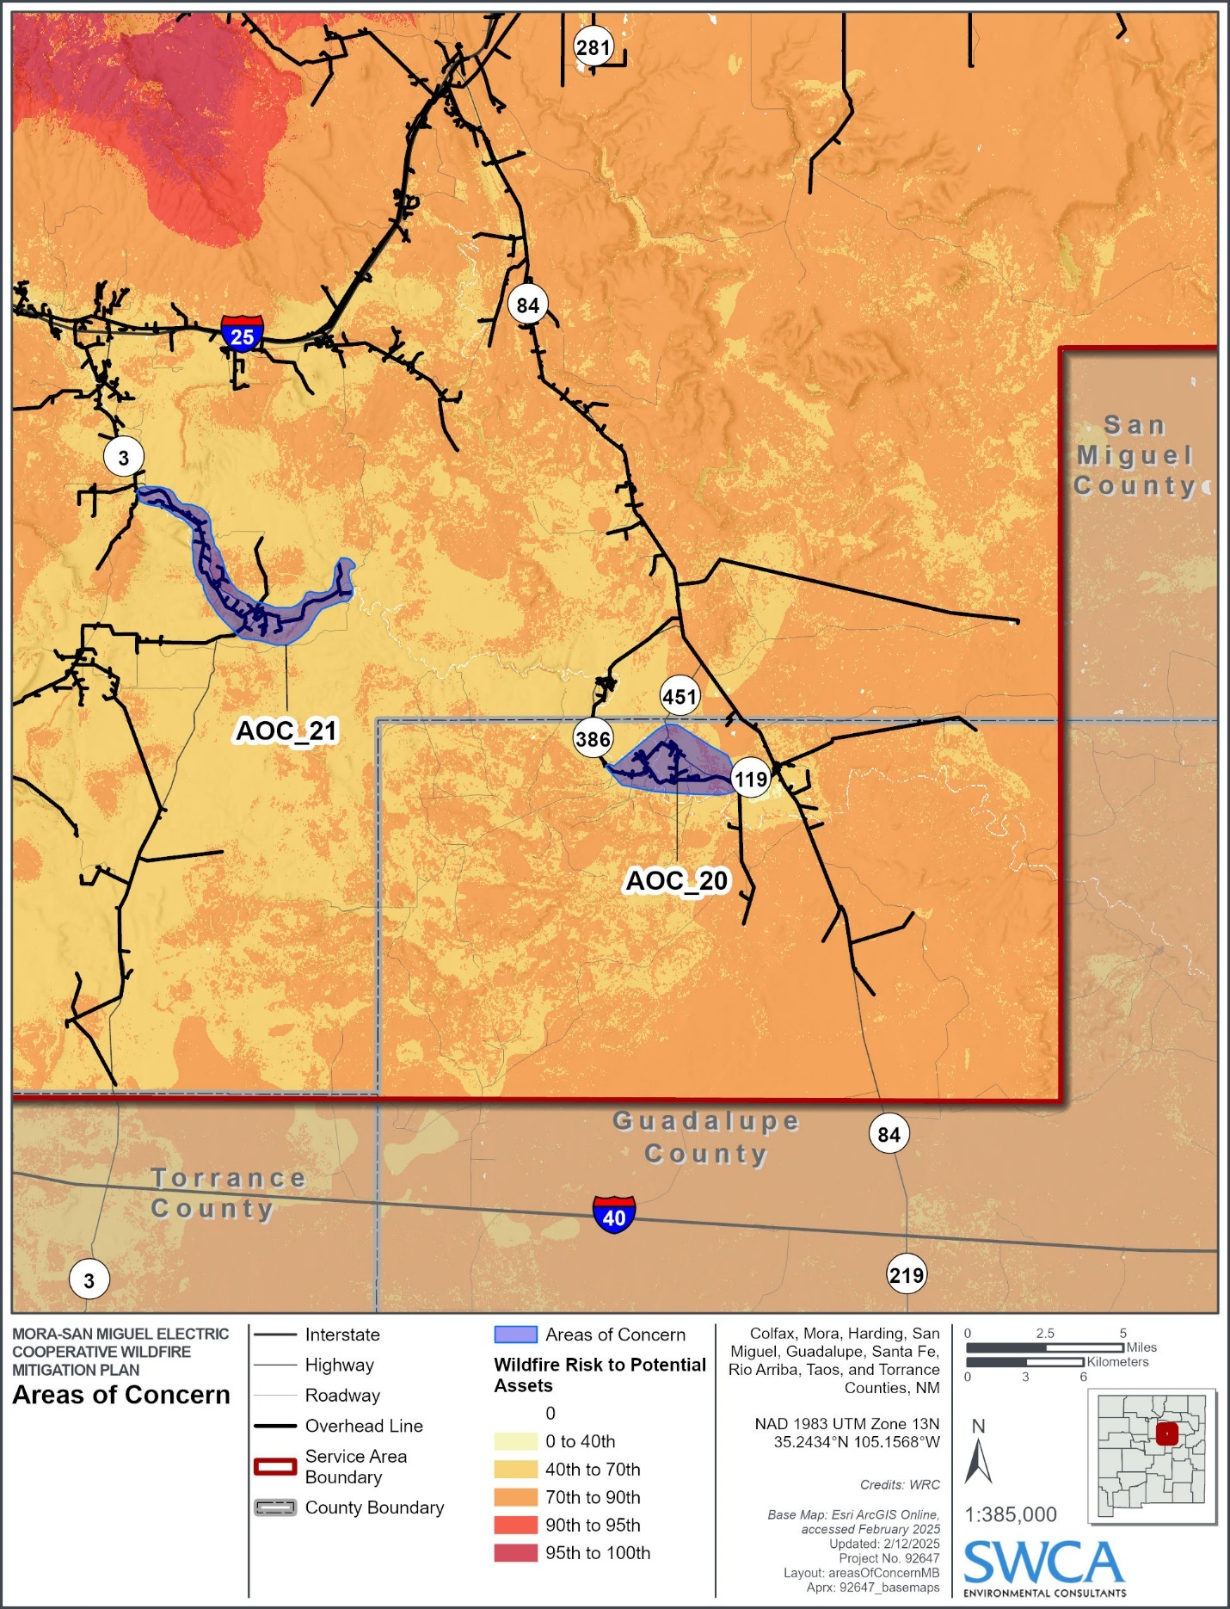

Grid Resilience and Infrastructure Project
The Grid Resilience and Infrastructure Project (GRIP) represents a transformative initiative for (MSMEC), aimed at significantly enhancing the resilience and reliability of the electric grid within its service territory. Funded under Agreement DE-GD0000893 with the U.S. Department of Energy, the GRIP project spans from September 1, 2024, to September 30, 2029. The project has secured a total budget of $15,345,140. These funds are strategically allocated across four phases to address wildfire risk through grid hardening, modernization, and enhanced vegetation management, with a strong focus on benefiting disadvantaged communities (DACs) in MSMEC's service area. See table 6 below for a breakdown of MSMEC’s planned projects, timelines, and budgets under the GRIP initiative.
The GRIP project is designed to enable MSMEC to better prevent, withstand, and recover from power disruptions, particularly those caused by wildfires. The project also aims to improve the System Average Interruption Duration Index (SAIDI) by at least 5%, reflecting a tangible enhancement in service reliability for MSMEC members.
Project Timeline:
Phase 1: Design, Permitting, and Siting (Sep 1, 2024 - Aug 31, 2026) Activities include system assessments using aerial imagery, field inventories, and the development of system coordination studies to inform grid hardening designs.
Phase 2: Procurement and Acquisition (Sep 1, 2026 - Oct 31, 2028) This phase focuses on acquiring materials and services necessary for vegetation management, system modeling, and grid modernization.
Phase 3: Construction and Deployment (Sep 1, 2027 - Sep 30, 2029) Implementation of grid hardening measures, distribution automation, and comprehensive vegetation management activities.
Phase 4: Testing and Commissioning (Feb 1, 2029 - Sep 30, 2029) Final testing of new systems, staff training, and the establishment of continuation plans to sustain project benefits beyond the grant period.
Table 6. MSMEC’s Planned Activities, Projects, and Budget Allocations under the GRIP Initiative
SOPO Task/Subtask # | SOPO Task/Subtask Title | Planned Start Date | Planned Completion Date |  | Planned Total Cost (DOE & Cost Share)
1 | Project Management, Planning, and Community Benefits | 9/1/2024 |  | 9/30/2029 | $1,570,983
1.1 | Project Management Plan (PMP) | 9/1/2024 |  | 10/31/2024 | -
1.2 | Community Benefits Plan | 9/1/2024 |  | 10/31/2024 | -
1.3 | National Environmental Policy Act (NEPA) Compliance | 9/1/2024 |  | 8/31/2026 | -
2 | System Assessment | 1/1/2025 |  | 6/30/2025 | $1,756,687
2.1 | Unmanned Aerial System Assessment | 1/1/2025 |  | 4/30/2025 | -
2.2 | Field System Inventory | 3/1/2025 |  | 6/30/2025 | -
3 | Mapping and Coordination Study | 7/1/2025 |  | 12/31/2025 | $676,354
3.1 | System Model | 7/1/2025 |  | 10/31/2025 | -
3.2 | Coordination Study | 11/1/2025 |  | 12/31/2025 | -
4 | Enhanced Vegetation Management | 1/1/2026 |  | 3/31/2026 | $194,654
4.1 | Enhanced Vegetation Management Plan | 1/1/2026 |  | 3/31/2026 | -
5 | Grid Modernization/Hardening | 1/1/2026 |  | 4/30/2027 | $719,329
5.1 | Distribution Line Hardening Design | 1/1/2026 |  | 4/30/2026 | -
5.2 | Distribution Automation Implementation Determination | 5/1/2026 |  | 4/30/2027 | -
5.3 | Work Management Information System | 8/1/2026 |  | 10/31/2026 | -
5.4 | Identify a Preferred Vendors List for Grid Hardening/Modernization | 11/1/2026 |  | 12/31/2026 | -
5.5 | Distribution System Hardening/Modernization Plan | 1/1/2027 |  | 3/31/2027 | -
6 | Mapping and Coordination Study | 4/1/2027 |  | 9/30/2027 | $329,009
6.1 | System Software Purchase | 4/1/2027 |  | 9/30/2027 | -
7 | Application of Enhanced Vegetation Management | 4/1/2026 |  | 4/30/2028 | $225,422
7.1 | Bid for Certified Arborist | 4/1/2026 |  | 7/31/2026 | -
7.2 | Enhanced Vegetation Management Work Bidding | 6/1/2026 |  | 4/30/2028 | -
7.3 | Landowner Support | 4/1/2026 |  | 4/30/2028 | -
8 | Grid Modernization/Hardening | 7/1/2027 |  | 10/31/2028 | $3,343,623
8.1 | Order Distribution Materials | 7/1/2027 |  | 6/30/2028 | -
8.2 | Hire New Employees and Order Ancillary Materials | 11/1/2027 |  | 10/31/2028 | -
9 | Application of Enhanced Vegetation Management Plan | 9/1/2027 |  | 9/30/2029 | $1,089,790
9.1 | Enhanced Vegetation Project Coordination and Management | 9/1/2027 |  | 7/31/2029 | -
9.2 | Tree Marking and Field Coordination | 9/1/2027 |  | 7/31/2029 | -
9.3 | Perform Vegetation Clearing | 11/1/2027 |  | 9/30/2029 | -
10 | Grid Modernization/Hardening | 10/1/2027 |  | 9/30/2029 | $2,932,755
10.1 | Project Coordination and Management | 10/1/2027 |  | 2/28/2029 | -
10.2 | Coordination Study Recommendations Implementation | 10/1/2027 |  | 7/31/2028 | -
10.4 | Work Management Implementation | 12/1/2028 |  | 2/28/2029 | -
10.5 | Distribution Automation Implementation | 3/1/2029 |  | 9/30/2029 | -
10.6 | Distribution Line Hardening Implementation | 2/1/2028 |  | 9/30/2029 | -
11 | Training | 2/1/2029 |  | 7/31/2029 | $951,525
11.1 | Mapping and Coordination Training | 6/1/2029 |  | 7/31/2029 | -
11.2 | Distribution Automation Training | 6/1/2029 |  | 7/31/2029 | -
11.3 | Work Management Information System Training | 6/1/2029 |  | 7/31/2029 | -
11.4 | Accounting Support and Training | 2/1/2029 |  | 7/31/2029 | -
12 | Continuation of Enhanced Vegetation Management Plan | 2/1/2029 |  | 7/31/2029 | $777,504
12.1 | Continuing Work Plan | 2/1/2029 |  | 7/31/2029 | -
13 | Continuation of Grid Modernization/Hardening Plan | 2/1/2029 |  | 7/31/2029 | $777,504
13.1 | Construction Standards | 5/1/2029 |  | 7/31/2029 | -

Transmission and Distribution System Operational Practices

De-energization – Public Safety Power Shutoff
A Public Safety Power Shutoff (PSPS) preemptively de-energizes power lines during high wind events combined with hot and dry weather conditions. When considering de-energization, MSMEC examines the impacts to fire response, water supply, public safety, and emergency communications.
MSMEC considers the external risks and potential consequences of de-energization while striving to meet its main priority of protecting the communities and members the cooperative serves. They include:
- Water supply loss: De-energization can affect production wells and pumping facilities, limiting the availability of water for firefighting during wildfires.
- Emergency response disruption: Extended power outages can negatively impact communications, particularly internet and mobile phone service, which are essential for coordinating emergency responses.
- Infrastructure impacts: Key community infrastructure, including medical facilities, may experience interruptions, affecting operational efficiency and endangering vulnerable populations.
- Public health risks: Medically vulnerable populations may suffer without power for essential medical equipment, refrigerated medication, or air conditioning, particularly during heatwaves.
- Traffic congestion: Evacuation efforts during PSPS events could lead to traffic delays, extending response times for emergency personnel.
- Economic impacts: Local businesses may be forced to close during outages, causing economic strain.
- Access challenges: Individuals may face difficulties opening motorized gates or garage doors, leading to injuries or fatalities if they are unable to evacuate.
The risks and potential consequences of initiating a PSPS are significant and extremely complex. Based on the above considerations, MSMEC reserves the option of implementing a PSPS when conditions dictate. While MSMEC believes the risks of implementing a PSPS far outweigh the chances of its electric overhead distribution system igniting a catastrophic wildfire, the PSPS provides a last-resort tool and another mitigation option in a potential crisis.
On a case-by-case basis, MSMEC has historically and will continue to consider de-energizing a portion of its system in response to a known public safety issue or response to a request from an outside emergency management/response agency. Any de-energizing of the lines is performed in coordination with key local partner agencies; however, the final determination is made by MSMEC.

Recloser Operational Practices
As part of MSMEC’s wildfire risk mitigation efforts the utility will work to implement alternate recloser setting protocols, particularly in areas classified as high-risk for wildfires. During periods of heightened fire danger, such as when Red Flag Warnings are issued, reclosers can be adjusted to “one-shot” mode. In this mode, reclosers would not attempt multiple reclosing cycles after detecting a fault, which can prevent potential sparks and ignition from downed or compromised power lines. These settings could be adjusted remotely or manually, with a focus on high wildfire risk areas.

Situational Awareness
Situational awareness involves understanding current operating conditions and how they evolve under changing circumstances. This understanding forms the basis for informed decision making and the ability to anticipate potential risks and challenges.
MSMEC system operators rely on various resources to monitor evolving fire weather and climatological conditions that may lead to fire events. Sources for weather information include, but are not limited to, the following:
- Rocky Mountain Area (RMA) Fire Area: For immediate and short-term situational awareness, the RMA fire dashboard provides real-time data and mapping tools to evaluate daily and forecasted fire weather conditions. This resource supports the identification of fire risks and helps guide operational decisions. (https://www.rmacc.info)
- The National Weather Service (NWS): The NWS provides online predictive fire weather forecasting tools in the form of a current fire weather outlook, 2-day outlook, and a 3- to 8-day outlook. (https://www.spc.noaa.gov/products/fire_wx/)
- NOAA Weather and Hazards Data Viewer: This online map provides historic or real-time surface observations including wind speed and direction, wind gust, dew point, relative humidity, and sea level pressure collected from remote automated weather stations (RAWS). Extreme weather alerts such as fire weather watch, high wind watch, and Red Flag Warning are provided from this resource. (https://www.wrh.noaa.gov/map/?wfo=psr)

Infrastructure Inspections and Maintenance
To establish an annual visual inspection program for overhead and underground distribution line facilities, for preventive maintenance purposes in the MSMEC service area. The inspection program is intended to constantly monitor the condition and performance of the MSMEC system to ensure the reliable delivery of service to all of its consumers, thereby creating a procedure to strengthen the effective and efficient line maintenance program.
The visual inspection will be initiated and scheduled by the Operations Managers and Operations Superintendent and performed in accordance with Rural Utilities Service (RUS) Bulletins 1730-1 (Electric System Operations and Maintenance) and 1730b-121 (Pole Inspection and Maintenance) to meet or exceed all standards that have been established.
The maintenance of the distribution system will be set as a priority system. The priorities adopted by MSMEC exemplify its philosophy of delivering reliable power. This priority system ensures that the most important maintenance work is done at a time it can be performed most cost-effectively. Minimizing outage time is part of the cost-effectiveness calculation. The maintenance priorities of MSMEC are the following:
- Emergencies
- Urgent
- Consumer on-demand request
- Scheduled operations and service

Definition of Inspection Levels
Various inspection levels are defined to provide clarity on the procedures and expectations associated with utility equipment and structure evaluations. While this is not a code requirement, the following descriptions offer a standardized approach for inspection practices:
- Routine Safety Patrol Inspection: A simple visual inspection of applicable utility equipment and structures designed to identify obvious structural problems and hazards. The inspection should ensure vegetation clearances and identify any potential strike trees or factors that could contribute to arcing and power failure. Patrol inspections may be carried out in the course of other company business.
- Detailed Inspection: Individual pieces of equipment and structures are carefully examined visually, or through the use of routine diagnostic testing.
- Intrusive Pole Inspection: Inspections involving the movement of soil, taking samples of the wood pole for analysis, and/or using more sophisticated diagnostic tools beyond visual inspections.
Table 7 summarizes the inspection schedule for all assets, while the following sections outline inspection practices for the utility.
Table 7. Inspection Program Schedule.
Asset Classification | Inspection Type | Frequency
Overhead Distribution | Routine Safety Patrol Inspection | Annually
 | Detailed Inspection | 3 years
 | Intrusive Pole Testing | 10 years
Underground Distribution | Routine Safety Patrol Inspection | 5 years
Substation (MSMEC owned distribution Infrastructure of the Storrie Lake and Rainsville substations) | Routine Inspection | Monthly
 | Detailed Inspection | Quarterly

Safety Patrol Inspections of Distribution Lines
Routine safety patrol inspections are conducted to identify visible hazards, such as damaged poles, vegetation encroachments, or sagging lines. Additional patrols are performed following severe weather events or other incidents that may affect system integrity. High-risk areas, such as wildfire-prone regions or those with known structural vulnerabilities, are prioritized for more frequent inspections. These inspections adhere to RUS Bulletin 1730b-121 standards, with the Operations Managers overseeing scheduling and ensuring proper execution (MSMEC 2019b).
All inspections are tracked using GPS-enabled devices, allowing precise location data for every asset inspected. Results are integrated into MSMEC’s geographic information system (GIS) platform, enabling visualization of inspection findings and their correlation with system maps, maintenance histories, and risk assessments. Inspection data are further incorporated into the work management information system for streamlined work order generation and task prioritization.
Data collected are systematically reviewed to:
- Identify and prioritize corrective actions, especially in high-risk wildfire areas.
- Inform maintenance schedules and capital improvement plans.
- Guide vegetation management to mitigate fire risks.
Deficiencies identified during inspections are categorized based on severity:
- Critical Deficiencies: Hazards such as leaning poles, conductor damage, or significant vegetation encroachments are addressed immediately, with work orders issued to resolve the issue as quickly as possible.
- Routine Maintenance: Non-critical issues, such as minor hardware repairs overgrown vegetation, potential strike trees, or aesthetic improvements, are incorporated into scheduled maintenance activities.

Detailed Inspections of Transmission and Distribution Lines
Detailed inspections are performed every 3 to 5 years, or sooner if warranted by environmental or operational factors. These inspections focus on evaluating individual components and identifying less apparent issues, such as hardware corrosion, structural weakening, or vegetation interference.
Inspection records, including diagnostic results and photographs, are retained to support compliance, trend analysis, and long-term maintenance planning.
Detailed inspections of transmission and distribution lines inform:
- Maintenance prioritization, especially in high-risk areas.
- Systematic planning for capital improvement projects and vegetation management.
- Allocation of resources for targeted repairs and upgrades.
Deficiencies identified during inspections are categorized based on severity:
- Critical Deficiencies: Addressed immediately, such as a conductor damage or poles at risk of failure.
- Routine Maintenance: Included in scheduled maintenance cycles.

Wood Pole Testing and Inspection
MSMEC maintains a proactive approach to wood pole safety and reliability by adhering to best practices outlined in RUS Bulletin 1730b-121. Wood poles are inspected on a planned cycle to identify signs of decay, structural weakening, or damage. The program aims to inspect 100% of the system on a rotational basis every 10 years, with approximately 10% of poles inspected annually. Wood pole inspections are carried out on a planned basis to determine whether they have degraded below NESC design strength requirements with safety factors.
A third-party contractor inspects and tests all poles on a cycle, meeting the interval recommended in RUS Bulletin 1730B-121. Circuits are identified, mapped, and scheduled for inspection and testing using latest industry standards and practices.

Substation Inspections
Substation inspections are completed by Tri-State who is contracted by MSMEC. Qualified personnel will use prudent care while performing inspections following all required safety rules to protect themselves, other workers, the general public, and the system's reliability.
The annual substation inspection involves a thorough look at the system to confirm that there are no structural or mechanical deficiencies, hazards, or tree trimming/vegetation management needs. Individual pieces of equipment and or structures receive careful visual examination and routine diagnostic tests as appropriate.

Integrated Vegetation Management
The MSMEC vegetation management program is guided by the Vegetation Management Policy and Procedure (VMPP) (see Appendix B). The primary objective of the VMPP is to provide safe, reliable, and economical delivery of electric energy to the public with ready access for facility maintenance or emergency repairs. The MSMEC’s secondary VMPP objective is to be an environmental leader and steward of the unique natural resources of its service area. MSMEC achieves these objectives by managing to enhance aesthetics, watershed protection, and habitat for pollinators, birds, wildlife, and endangered species, while reducing invasive plants, erosion, stream sedimentation, and wildfire risk.
MSMEC utilizes an integrated vegetation management (IVM) strategy using best practice techniques to encourage stable, early successional plant communities that provide multiple benefits by controlling plants not compatible with the utility’s goals. MSMEC uses a variety of methods to manage vegetation, including the following (USFS 2022).
Manual:
Manual treatment involves the targeted use of hand tools and hand-operated power tools to reduce fuels, either performed by a single individual or an organized crew with power equipment. Manual treatment is effective for the removal of vegetation that occurs in lower amounts throughout a defined area. Because of the labor involved with manual vegetation treatment, these activities are often best suited for smaller projects unless other options are unavailable.
Mechanical:
Mechanical methods include physical cutting actions to destroy or remove plants by cutting, uprooting, or chopping existing vegetation. Specific examples of mechanical treatment include mowing or discing weed populations and plant pulling by using motorized hand tools. Other treatments include thinning, chipping, crushing, hand and machine piling, masticating, and lopping and scattering small trees, shrubs or limbs. Mechanical treatments are particularly effective in areas where terrain or accessibility make other methods, such as herbicide application, less practical. These methods are used to maintain safe clearances around electrical infrastructure and reduce potential fire hazards associated with overgrown vegetation (USFS n.d.). MSMEC focuses on mechanical treatment as a standalone approach or in conjunction with other non-burning strategies to ensure safe and reliable vegetation management. (National Interagency Fire Center [NIFC] n.d.; USFS n.d.).
Biological:
Biological treatments involve the use of domestic animals, insects, nematodes, mites, or pathogens that weaken or destroy vegetation. Domestic animals such as sheep, goats, cattle, and horses may be used for targeted grazing. Biological treatments may reduce targeted weed populations by stressing target plants and reducing competition with desired plant species (NIFC n.d.).
Chemical:
Chemical treatments may remove weed species using herbicides. Herbicide treatments may be temporarily effective for large populations of weeds when other treatment options are not feasible or available. Growth regulators may also be used during chemical treatments. These types of treatments are commonly applied following removal of vegetation after a mechanical or prescribed fire treatment. Oftentimes, native vegetation is seeded or planted to improve fire resilience in the future (NIFC n.d.).
Additionally, cultural techniques such as hand cutting, mowing, tree pruning, and tree removal may be used as a vegetation management strategy.
The VMPP provides procedures for IVM, including specifics around offices and substations, transmission ROWs, distribution ROWs, and ROW vegetation work. The VMPP goes into further detail regarding the IVM strategy including planning for vegetation management, the removal of brush and trees, tree pruning, off-ROW danger trees, timber harvesting, the vegetation management of threatened and endangered heritage sites, vegetation management of archaeological sites, vegetation management adjoining highways, forest fire mitigation, and annual vegetation work plans. The VMPP provides specific guidance and operating procedures concerning the above vegetation management practices.

Vegetation to Conductor Clearance
MSMEC will meet the minimum standards for conductor clearances from vegetation to provide safety for the public and utility workers, reasonable service continuity, and fire prevention. As an operator of electric supply facilities, MSMEC’s IVM program will keep appropriate records to ensure that IVM is accomplished to maintain the designated clearances. These records will be made available for RUS operations and maintenance inspections upon request.
MSMEC has an operational and management responsibility and is required by state and federal agencies to maintain the ROW, under or around its power lines. To lessen the liability of fire and safety hazard due to live, dead, or leaning trees and vegetation, MSMEC crews work on an ongoing effort to clear any such hazard by removing any tree or brush that is directly under the power line and considered a problem at the stump to the full ROW width or forest line (whichever is greater). Trees or vegetation located outside of the power line but encroaching inside the ROW shall be trimmed or removed as needed.
During tree work, contractors aim to achieve a minimum of 10 feet of clearance, unless otherwise directed by MSMEC IVM staff, and overhanging limbs are removed. The contractor also clears vegetation from MSMEC’s service drops and pole climbing space on an as-needed basis.
The following are optimal clearance dimensions or trimming operations:
- Overhead Distribution: Maintain a minimum clearance of 20 feet from the conductor.
- Transmission ROW (defined width): Ensure a minimum of 20 feet of clearance between the conductor and the rooted tree stem. Defined-width ROWs are generally found on cross-country corridors.
- Trees Under Conductors: Reduce the crowns of trees under conductors to a height at least 15 feet below the primary conductors, or remove the trees entirely.
- Overhanging Branches: Remove all branches overhanging transmission and distribution lines.
- Secondary Conductor: Prune trees around secondary conductors to maintain a minimum clearance of 15 feet.
- Service Wire: Remove branches that weigh heavily on or deflect service or other secondary wires beyond the last MSMEC pole. Full pruning is not performed unless directed by MSMEC operations.
- Pole Base: Maintain a 10-foot radius around the base of all poles, clearing any vegetation that could obstruct safe access or climbing.
- Brush Removal: Remove brush up to 10 feet beyond the maximum side clearance to ensure adequate safety and accessibility.

Vegetation Trimming Standards
MSMEC’s contractors follow American National Standards Institute (ANSI) A300 Part 1-1001 and Part 7-2012 standards, concepts, and utility directional pruning, which supports proper pruning/tree health while achieving and maximizing the pruning cycle. The IVM program was developed with ANSI Z133, ANSI 2006, NESC 2007, RUS, IWUIC 2012, USFS Code of Federal Regulations (CFR) Title 36, National Historic Preservation Act (NHPA), CFR Part 800 Section 106, Section 1 of the NHPA, and Public Law 89-665 standards.
Work performed to the above guidelines provides reasonable service continuity and public safety, and guards against wildfire damage caused by supply conductors. Consideration is given to the impact of pruning on power line reliability, individual tree condition, and tree aesthetics. All work is conducted in a safe manner in accordance with the work rules set forth in OR-OSHA 1910.269 and MSMEC’s Technical Guidelines.
Vegetation crews shall be equipped with portable fire suppressor equipment (portable extinguisher, portable water tank, etc.) to suppress any fire resulting from sparks while operating chainsaws and other cutting equipment.

Vegetation Trimming and Inspection Schedule
MSMEC personnel and contractors perform annual, ground-based inspections of tree conductor clearances and hazard tree identification for MSMEC ROWs and easements and develop work plans based on these annual inspections. Proactive maintenance during routine operations and prompt action during emergency events maintain system reliability, a safe work environment, and reduce fire danger. Scheduled patrols ensure all lines are inspected for vegetation hazards and systematically trimmed. Ongoing, year-round field patrols identify targeted areas for vegetation pruning or removal and ensure compliance with state and federal regulatory requirements.

Hazard Trees
A subset of danger trees0F, a hazard tree is defined as any tree or portion of a tree that is dead, rotten, decayed, or diseased and that may fall into or onto the overhead lines or trees leaning toward transmission and distribution facilities. These trees are sometimes located beyond the easement or ROW. Any tree that is located outside of the ROW and is deemed a hazard tree will be removed or topped to make it safe for conductors.
A hazard tree will have one or more of the following characteristics:
- Dead or dying: all dead or dying trees along, or outside the MSMEC ROW may be removed depending on the height of the tree and the direction of the lean.
- Leaning trees: trees that have such a lean toward the ROW that they cannot be trimmed without removing the tops and slanting the tree back. Removal depends on height and species of the tree and direction of the lean.
Large areas of the service area have been affected by bark beetle infestation, causing many trees in the service area to become hazard trees. No danger or hazard trees are cut or removed if they cannot make contact with the conductors or structures or cause adjacent trees to fall into the power lines.

Revegetation Practices
MSMEC commits to revegetation practices, which entails reestablishing native vegetation in the service area. Revegetation and restoration of an ecological area can help reestablish vegetative structure and function, reducing the risk for future fire damage. Revegetation practices may include planting fire-adapted native species in the service area, avoiding planting flammable or species that risk becoming invasive, and ensuring that the service area includes defensible space surrounding infrastructure. Each of these techniques may reduce the risk of future wildfire damage.
In addition to the annual patrols by MSMEC field staff observing and reporting on incompatible uses and encroachments, MSMEC makes efforts to educate the public and private landowners about incompatible vegetation that can pose risks if planted under or near conductors.
Vegetation work is scheduled with time allotted for obtaining private landowner notification or permission, permits, and other regulatory requirements, and the MSMEC Operations Manager shall notify the system operator and dispatch prior to work commencement to coordinate with line crew operation and landowner communication. Attempts to contact absent landowners include notification by door hanger, postcard, or another form of communication.

Fire Mitigation Construction
MSMEC implements fire mitigation construction standards to reduce wildfire risks and enhance the reliability of its infrastructure. These practices reflect industry best practices, integrating both proven methods and potential future upgrades. Current and planned practices include:
- Steel poles: Steel poles may be used in areas with high wildfire risk due to their increased durability and fire resistance compared with traditional wood poles.
- Increased conductor spacing: MSMEC evaluates and implements increased spacing between conductors in areas prone to wind events or other conditions that could lead to conductor contact and sparking.
- Undergrounding of distribution lines: While undergrounding is not standard across the entire system, MSMEC considers this option in critical, high-risk zones to reduce ignition potential.
- Fireproof pole-wrap or coatings: MSMEC is exploring fireproof pole-wraps or coatings as a measure to protect wooden poles in wildfire-prone areas.
- Non-expulsion fuses: Non-expulsion fuses are part of MSMEC’s grid modernization efforts to reduce sparking during fault events.
- Polymer crossarms: MSMEC uses polymer crossarms, which are more resistant to fire and environmental wear compared with traditional wooden crossarms.
- Single-phase conductors with multiple tree hazard conditions, especially in high fire danger areas, as determined through MSMEC’s inspection program, shall be evaluated with consultation with engineers for possible placement underground or other construction changes, i.e. alley arms, tree wire.

Avian Protection Program
While MSMEC does not currently have a formal avian protection program, the cooperative recognizes the importance of protecting avian species and minimizing potential wildlife impacts associated with its infrastructure. MSMEC will work on creating and implementing a formal avian protection program using wildfire mitigation grant funds as part of GRIP.

Emerging Technologies
MSMEC is actively exploring and implementing a range of emerging technologies to enhance grid resilience and improve wildfire mitigation. These efforts are guided by the goals of increasing system reliability, reducing ignition risks, and modernizing infrastructure to withstand future challenges. The following pilot projects and technology adoptions demonstrate MSMEC’s commitment to innovation:
- Non-expulsion fuses: MSMEC is introducing sparkless fuse technology in high-risk areas as part of its grid modernization efforts.
- Drone inspection program: MSMEC uses uncrewed aerial systems (UAS) equipped with LiDAR technology to assess vegetation conditions and identify hazard trees in and outside of the ROW.
- High impedance fault detection: As part of the grid modernization efforts, MSMEC is piloting devices capable of detecting high impedance faults, which can help prevent power system failures and mitigate fire risks.​
- Ultraviolet (UV), LiDAR, infrared (IR) inspection: In addition to LiDAR, MSMEC is employing UV and IR technologies to detect potential equipment failures and improve predictive maintenance.
- Utility-owned weather stations: MSMEC plans to install utility-owned weather stations to monitor localized weather conditions. These stations will support fire prevention strategies and provide critical data to guide operational decisions during fire-prone periods.
- Reclosers with automation capability: MSMEC is investing in automated reclosers that allow for remote operation, reducing response times and minimizing risks associated with manual intervention in fire-prone conditions​.
- Fireproof wood coatings: Pilot projects are evaluating the application of fire-resistant coatings on wooden poles to enhance their durability and reduce ignition potential during wildfires.
MSMEC has initiated various pilot projects to explore new technologies and best management practices. These pilot projects will serve to evaluate the effectiveness of emerging technologies while controlling unwarranted expenditures on unproven methods. MSMEC may elect to integrate these technologies or practices into its ongoing maintenance programs based on the outcomes. These technologies include, but are not limited to, non-expulsion fuses, thermal imaging cameras, high impedance faults, MSMEC-owned weather stations, electronic reclosers, and fire protective coatings for wood poles.

Emergency Response

Preparedness and Response Planning
MSMEC has implemented measures to minimize the impact of emergencies or disruptive events, regardless of their size or scope. The MSMEC Emergency Action Plan (EAP) (Board Policy No. 218) is designed to ensure the safety and well-being of all employees and customers. To promote awareness and understanding of emergency procedures, MSMEC provides training and education to all staff. A copy of the EAP is given to each employee upon hire and is available at any time upon request.
The EAP outlines the process for reporting emergencies and details various emergency situations that employees may encounter, such as building, equipment, or vehicle fires. It includes comprehensive evacuation procedures, as well as lockdown procedures and last-resort defensive measures for situations requiring building lockdowns.
For first aid, rescue, medical duties, and fire response, employees are instructed to perform basic first aid and handle small fires. However, they are advised to leave medical emergencies and larger fires to professional responders, especially when the situation exceeds the capabilities of an extinguisher.

Emergency Management Communication and Coordination
MSMEC’s Hazard Recognition and Reporting Policy (Board Policy No. 223) aims to create a safer workplace and a more reliable electrical system. This policy establishes a structured approach for reporting, tracking, and documenting the correction of hazards. It clearly outlines the responsibilities of employees, requiring them to report hazards when notified or observed, whether on or off duty. On-duty employees must report hazards to the Operations Department. High-priority hazards observed off duty should be reported immediately to dispatch or the MSMEC employee on call, while low-priority hazards observed off duty should be reported to the Operations Department on the next workday. MSMEC employees undergo annual training to ensure proficiency in electrical hazard reporting in the field (Board Policy 223).
During active emergencies, the EAP advises calling 911 immediately and providing a detailed description of the emergency, including the location, type of emergency, persons involved, actions being taken on-site, and the name of the employee making the call. The MSMEC “Mayday” Emergency Reporting Procedures (Board Policy No. 220) outline the steps to be taken by employees experiencing or involved in a life-threatening emergency that requires immediate notification and response from first responders. Once the initial notification and response efforts have been completed as outlined in the policy, the “Mayday” Procedures and Intake form must be filled out and submitted to management.
Emergency situation reporting is further facilitated through the MSMEC Two-Way Radio Dispatch Operation Policy (Board Policy No. 219), which establishes a communication protocol using two-way radios equipped on MSMEC vehicles and equipment. This system allows employees to maintain communications with headquarters, supervisors, and coworkers during working hours. Emergency situations and essential information surrounding the incident are to be reported to headquarters dispatch.

Jurisdictional Structure
The service area of MSMEC covers a diverse range of land ownership and management in New Mexico, which plays a crucial role in wildfire mitigation strategies. The emergency response procedures within the region involve efforts from the USFS, USFWS, NPS, BLM, and New Mexico State agencies that emphasize a coordinated, multi-agency approach to ensure effective management of fire emergencies.
The USFS focuses on risk reduction, proactive suppression, and close coordination with state and local agencies during emergency incidents (USFS 2022). NPS emergency response efforts are guided by NPS management policies, which prioritize saving human life above all other management actions and, if necessary, supporting emergency response efforts outside of the park for incidents that involve actions such as firefighting or search and rescue (NPS 2024). New Mexico State land, under the New Mexico All-Hazard Emergency Operations Plan, integrates various government levels and agencies, using the Incident Command System (ICS) and Multi-Agency Coordination Systems (MACS) for clear leadership and communication (New Mexico Department of Homeland Security and Emergency Management 2013). The USFWS provides emergency support through the National Response Framework, maintaining radio communication system and a team of firefighting personnel, assisting federal and state agencies as needed (USFWS n.d.). The BLM New Mexico Unit manages fire suppression and hazardous fuel reduction in the region, supporting local departments, providing excess equipment, and hosting air tanker bases for fire suppression (BLM n.d.).

Public Agency and Customer Communications for Outages
MSMEC’s Interruption Reporting Policy (Board Policy No. 222) outlines the procedures for responding to and reporting interruptions and outages. This policy defines various causes of interruptions, characterized as a loss of electricity exceeding 5 minutes, and specifies relevant codes related to the cause and nature of these interruptions. The primary goal is to ensure consistent reporting, response, and documentation of interruptions and outages, enabling performance benchmarking and providing valuable data to improve system reliability.
Interruption reports are generated from "Trouble Tickets," which contain information regarding reported interruptions, primarily from consumers calling to report service issues. Calls made during the workweek are handled by MSMEC employees, while after-hours calls are managed by dispatch. The Trouble Ticket or information regarding the service interruption is forwarded to linemen, who then respond to the issue. The work done by linemen to restore power is documented in an Interruption Report. These reports are reviewed by Operations Managers and provided to Human Resources when requested to support claims filed by customers resulting from the interruption.
MSMEC compiles Interruption Reports for a given month into a Monthly Interruption Report, which is provided to the Board of Directors and included in Annual Reports for Outages and for calculating the System Average Interruption Duration Index.

Community Outreach
The MSMEC website features comprehensive documentation on the cooperative’s emergency and safety policies, along with essential safety information available under the "Safety and Outages" tab. This section covers key topics such as electrical safety, generator usage, and how to report outages.
MSMEC advises never to touch downed power lines and to assume all ground wires are live, urging immediate reporting to the cooperative. If water reaches electrical outlets, contact a licensed electrician before using the main circuit breaker to avoid fire and shock hazards. Submerged electrical appliances should be dried and inspected by a qualified repair person before use. Damaged cords should be replaced, and portable generators should be used according to manufacturer instructions, avoiding overloads and ensuring proper cord conditions. Generators should never be connected to power lines to prevent electrocution risks to utility workers.
For power outages, consumers are advised to check their breaker boxes for issues before contacting MSMEC, and to verify whether the outage affects others in the neighborhood. Contact numbers for outage reporting are provided for the Mora and Pecos offices.

New Mexico Electric Cooperative Mutual Aid Agreement
The New Mexico Mutual Aid Agreement is a formal arrangement among various electric cooperatives in New Mexico to provide mutual aid in times of need. The agreement outlines the responsibilities and procedures for both requesting and assisting cooperatives. It is emphasized that all aid provided must be consistent with the terms set forth by the agreement and that the decision to provide assistance is at the discretion of the management of each cooperative. The agreement is designed to align with Federal Emergency Management Agency (FEMA) requirements but does not include specific safety rules, which are managed individually by each cooperative.
Outlined within the New Mexico Mutual Aid Agreement are the responsibilities and procedures that both the requesting and the assisting cooperatives must adhere to in accordance with the terms of the agreement. Resources to be provided by the assisting cooperative may include, though are not limited to, 1) line personnel (preferably line/crew foreman, journeymen, apprentice, groundmen, and/or digger‐operator) with all necessary equipment; 2) staking technicians with all necessary equipment (e.g., vehicle, laptop, tablet, iPad, staking software if compatible, etc.); 3) warehouse personnel; 4) vehicle mechanics; and 5) customer services or coordinating personnel. The agreement also includes indemnification clauses to protect both parties from liability arising from negligence. Amendments to the agreements are governed by New Mexico law. Provisions to ensure appropriate compensation for out-of-state work are included.

Restoration of Service
If an outside emergency management/emergency response agency requests a power shutdown, or if MSMEC elects to de-energize segments of its system due to extreme weather, MSMEC staff will patrol the affected portions of the system before the system can be re-energized. Potentially faulty equipment or distribution lines that cannot immediately be patrolled will remain de-energized until MSMEC staff can do so. Poles and structures damaged in a wildfire must be assessed and rebuilt as needed prior to re-energization. Periodic customer and media updates of restoration status prior to full restoration will be made (MSMEC 2019a).

Service Restoration Process
MSMEC will attempt to restore service as quickly and safely as possible. After a widespread outage, MSMEC work crews take the following steps before restoring electrical service after a de-energization event. These measures intend to protect the worker, members, the public, and the system’s reliability.
- Communication: MSMEC will ensure a combination of maintenance staff and dispatch personnel are available 24 hours per day, 7 days per week to respond to customer outages. Communication between dispatch and operational crews has been streamlined to allow for quick response to outages.
- Patrol: Crews patrol every de-energized line to ensure no hazards have affected the system during the outage. If an outage is due to wildfire or other natural disasters, as soon as it is deemed safe by the appropriate officials, crews inspect lines and equipment for damage and foreign contacts and estimate equipment needed for repair and restoration. Lines located in remote and rugged terrain with limited access may require additional time for inspection. MSMEC personnel assist in clearing downed trees and limbs as needed.
- Isolate: Isolate the outage and restore power to areas not affected.
- Repair: After the initial assessment, MSMEC staff will coordinate priority actions. Rebuilding commences as soon as the affected areas become safe. Repair plans prioritize substations and transmission facilities, then distribution circuits serving the most critical infrastructure needs. While the goal is to re-energize all areas as soon as possible, emergency services, medical facilities, and utilities receive first consideration when resources are limited. Additional crew and equipment are dispatched as necessary.
- Restore: Updates on restoration status are periodically shared with customers and the media through social media platforms and MSMEC’s website prior to full restoration. After repairs are made, power is restored to homes and businesses as quickly as possible. Members, local news, and other agencies receive notification of restored electric service.

Performance Metrics and Monitoring

Plan Accountability
MSMEC’s management holds critical responsibilities for overseeing the WMP, ensuring that all activities are carried out efficiently and effectively. The Board of Directors is tasked with making policy decisions related to the utility and holds the ultimate responsibility for approving and adopting the WMP. The General Manager is responsible for the overall execution of the WMP, directing staff on their specific roles and responsibilities to support the plan's implementation. The General Manager plays a vital role in communication, liaising with public safety officials, media outlets, public agencies, first responders, the local Office of Emergency Management, and other local, state, and federal emergency response agencies during emergencies or planned maintenance outages. In the event of wildfire emergencies, the General Manager determines the appropriate timing and methods for notifying external agencies. Additionally, the Operations Manager is responsible for monitoring and auditing the targets specified in the WMP to ensure that its objectives are met and overseeing the general implementation of the plan. This structured approach ensures that MSMEC’s management and operational teams work cohesively to mitigate wildfire risks effectively.

Monitoring and Auditing of the WMP
The WMP will undergo an annual review prior to the next fire season to ensure that it remains current and incorporates any new knowledge or insights gained over the preceding year. This process allows for timely updates and modifications to the plan, ensuring it continues to address emerging challenges and opportunities effectively. Additionally, a more comprehensive and formal review of the WMP will occur every 5 years, aligned with MSMEC’s business planning cycle. This periodic in-depth review ensures that the WMP remains robust and effective amidst evolving environmental conditions, legislative changes, and shifting planning requirements. By adhering to this structured review schedule, MSMEC can continually enhance its wildfire mitigation strategies, maintaining resilience and preparedness in the face of dynamic circumstances.

Identifying Deficiencies in the WMP
The General Manager will be responsible for ensuring that this WMP meets all public agency guidelines to mitigate the risk of its assets becoming the source or contributing factor of a wildfire. Staff responsible for assigned mitigation areas have the role of vetting current procedures and recommending changes or enhancements to build upon the strategies in the WMP. Either due to unforeseen circumstances, regulatory changes, emerging technologies, or other rationales, deficiencies within the WMP will be sought out and reported to the Board of Directors in the form of an updated WMP on a 5-year basis.

Performance Metrics
To ensure the success and continual improvement of the WMP, MSMEC will monitor a set of controllable performance metrics over time. The primary goal of these metrics is to provide a data-driven evaluation of the plan's performance. By systematically tracking these indicators, MSMEC can determine the effectiveness of the overall plan and identify areas that may require adjustments or enhancements. This approach facilitates adaptive planning and prolonged effectiveness in the face of ever-changing wildfire conditions.
Table 8 outlines several key metrics, their rationale, indicators, and measures of effectiveness.
Table 8. Performance Metrics.
Metric | Rational | Indicator | Measure of Effectiveness
Red Flag Warning (RFW) days in service area | Used to adjust annual variation in criteria | Number of RFWs during analysis cycle | N/A
Utility-caused ignitions | Demonstrates the effectiveness of the plan | Count of events | Reduction or no material increase
Ignitions in high wildfire risk areas | Assess system hardening efforts in critical areas | Count of events | Reduction in the general trend of events
Power line down in high wildfire risk areas during fire season | Assess system hardening efforts in critical areas | Count of events | Reduction in the general trend of events
Faults in transmission infrastructure in high wildfire risk areas | Assess system hardening efforts in critical areas | Count of events | Reduction or no material increase
Vegetation-caused outage during fire season | Assess vegetation management program work schedules/QC process | Count of events | Reduction or no material increase
Vegetation-caused ignition | Assess vegetation management program work schedules/QC process | Count of events | Reduction or no material increase

Programmatic Quality Assurance/Quality Control Processes
MSMEC will put in place a long-range maintenance planning work plan in order to ensure the most cost-effective use of resources and the maximum useful life of MSMEC's properties. Operations Managers shall provide input into the development of long-range work plan and will develop an equipment-specific long-range planning program that includes the following:
- Equipment maintenance standards.
- An estimate of the work to keep the facilities at or above the maintenance standard.
- An estimate on preventive maintenance, outage times, inspection requirements, and on-demand work from consumers.
In order to allow its staff members to perform to the best of their abilities, MSMEC recognizes the importance of providing staff with opportunities to refine technical skills, increase and expand craft skills, and learn new procedures. Each employee must demonstrate basic skills in the maintenance of MSMEC’s facilities and must attend safety training meetings annually. The Operations Manager is responsible for developing an on-the-job training curriculum for the departmental staff and working with personnel department staff to identify the means of delivering the training.

Transmission and Distribution System Inspection Quality Control Process
Ensuring the integrity and reliability of MSMEC's transmission and distribution systems is paramount to the success of the WMP. A robust quality control (QC) process is in place to review asset inspections, ensuring that all identified issues are addressed promptly and effectively (MSMEC 2019b).
The QC process for transmission and distribution system inspections involves a systematic review of inspection records, corrective maintenance activities, and diagnostic test results. This process is designed to verify that inspections are conducted thoroughly and that any identified issues are resolved in a timely and effective manner. The Operations Manager is responsible for overseeing this QC process and plays a critical role in ensuring the reliability of the system. The Operations Manager monitors inspection records to ensure that all assets are inspected according to the established schedule and that the inspections are conducted to the highest standards and also reviews corrective maintenance records to confirm that any issues identified during inspections are addressed promptly and appropriately. Additionally, the Operations Manager analyzes diagnostic test results to identify any emerging issues that may require attention.

Vegetation Management Quality Control Process
Ensuring adequate clearance of vegetation from power lines is crucial for mitigating wildfire risks and maintaining the reliability of MSMEC's electrical infrastructure. The vegetation management QC process is designed to ensure that tree trimming and vegetation management activities are performed to the highest standards, providing the necessary clearances to prevent vegetation-related outages and ignitions.
This process includes a comprehensive review process to assess the effectiveness and quality of tree trimming work. These reviews involve regular audits of the vegetation management activities to ensure compliance with established clearance standards and protocols. During the auditing process, a percentage of the power lines are inspected to verify that the vegetation has been adequately cleared and that the work meets the required specifications. This percentage is determined based on risk assessment prioritization and regulatory requirements, ensuring that the most critical areas are prioritized for inspection. The goal is to ensure that a representative sample of the vegetation management work is evaluated for quality assurance purposes. The Operations Manager oversees the entire QC process, ensuring that the audits are conducted systematically and that any identified issues are addressed promptly.
Record retention protocols are an essential component of the QC process. All audit findings, including inspection reports and corrective actions taken, are to be documented and retained in accordance with MSMEC's records management policies. These records are stored in a centralized database, allowing for easy access and retrieval for future reference and regulatory compliance. The retention period for these records is aligned with industry standards and regulatory requirements, ensuring that all relevant information is preserved for an appropriate duration.

Plan Approval Process

Public Comment
Public input is essential to the development of the WMP. To facilitate this, MSMEC will make a draft copy of the WMP available to the public for a 30-day period. The draft plan will be accessible on MSMEC's website, at the main office, and at designated public libraries within the service area. Notices about the plan's availability and the public comment period will be disseminated through local newspapers, social media, and community bulletin boards.
Comments can be submitted through various methods, including an online submission form on MSMEC's website, email, mail, and in-person at public meetings held during the comment period. All feedback will be reviewed by the WMP planning team, and a summary of the comments and responses will be presented to the Board of Directors before the plan's adoption. This process ensures that community concerns are addressed, enhancing the plan's effectiveness and fostering public trust.

Board Presentation
The process for the adoption of the WMP by MSMEC involves a formal presentation to the Board of Directors. This presentation provides an overview of the WMP, including key strategies, objectives, and the feedback received during the public comment period. The Board will review the plan, deliberate on its contents, and address any final questions or concerns.
Following the presentation, the Board will vote on the adoption of the WMP. Meeting minutes and any additional information discussed during the Board presentation will be documented and can be added as an addendum to the final WMP. This ensures transparency and provides a comprehensive record of the decision-making process leading to the plan's adoption.

References
Bureau of Land Management (BLM). n.d. New Mexico Fire Information. Available at: https://www.blm.gov/programs/public-safety-and-fire/fire-and-aviation/regional-info/new-mexico. Accessed December 2024.
———. 2024. BLM National Data Viewer Available at: https://experience.arcgis.com/
experience/9a89ee80c604431e8f8d939a186fbdbb#widget_6=active_datasource_id:dataSource_2,center:-11723861.775377374%2C4231573.395454789%2C102100,
scale:267715.60808133153,rotation:0,viewpoint:%7B%22rotation%22%3A0%2C%22scale%22%3A267715.60808133153%2C%22targetGeometry%22%3A%7B%22spatialReference%22%3A%7B%22latestWkid%22%3A3857%2C%22wkid%22%3A102100%7D%2C%22x%22%3A-11723861.775377374%2C%22y%22%3A4231573.395454789%7D%7D. Accessed December 2024.
Liu, Y.; Stanturf, J.A.; Goodrick, S.L. 2009. Trends in global wildfire potential in a changing climate. Forest Ecology and Management 259:685-697. 697.
Mora County. 2019. Community Wildfire Protection Plan (CWPP). Available at: https://www.emnrd.nm.gov/sfd/wp-content/uploads/sites/4/MoraCountyCWPP2019.pdf. Accessed December 2024.
Mora San Miguel Electric Cooperative (MSMEC). 2019a. Interruption Reporting Policy. Available at: https://morasanmiguel.coop/sites/msmec/files/downloads/board/policies/222%20Interruption%20Reporting%20Policy.pdf. Accessed December 2024.
———. 2019b. Hazard Recognition and Reporting Policy. Available at: https://morasanmiguel.coop/sites/msmec/files/downloads/board/policies/223%20Hazard%20Recognition%20and%20Reporting%20Policy.pdf. Accessed December 2024.
———. 2024a. Board. Available at: https://morasanmiguel.coop/board. Accessed December 2024.
———. 2024b. Contact Us. Available at: https://morasanmiguel.coop/contact-us. Accessed December 2024.
National Interagency Fire Center (NIFC). n.d. BLM Fuel Treatments. Available at: https://www.nifc.gov/about-us/our-partners/blm/fuels/treatments. Accessed December 2024.
National Oceanic and Atmospheric Administration (NOAA). 2000. Severe Weather Climatology for New Mexico. Available at: https://repository.library.noaa.gov/view/noaa/6488/noaa_6488_DS1.pdf. Accessed December 2024.
———. 2024. NOWData – National Weather Service. Available at: https://www.weather.gov/wrh/Climate?wfo=abq. Accessed December 2024.
National Park Service (NPS). 2024. About Us: NPS Severe Weather and Natural Disaster Response. Available at: https://www.nps.gov/aboutus/news/severe-weather-response.htm#:~:text=The%20NPS%20also%20has%20authority,or%20public%20safety%20and%20security. Accessed December 2024.
Natural Resources Conservation Service. n.d. NRCS New Mexico's Hermit's Peak/Calf Canyon Disaster Assistance. Available at: https://www.nrcs.usda.gov/conservation-basics/conservation-by-state/new-mexico/nrcs-new-mexicos-hermits-peakcalf-canyon#:~:text=In%20the%20summer%20of%202022,342%2C000%20acres%20(over%20500%20sq. Accessed December 2024.
New Mexico Department of Homeland Security and Emergency Management. 2013. All-Hazard Emergency Operations Plan. Available at: https://www.animallaw.info/sites/default/files/New%20Mexico%20All%20Hazard%20Emergency%20Response%20Plan.pdf. Accessed December 2024.
New Mexico Rural Electric Cooperatives. n.d. Mora-San Miguel Electric Cooperative. Available at: https://www.nmelectric.coop/mora. Accessed December 2024.
New Mexico State University, College of Agricultural, Consumer, and Environmental Sciences. 2011. New Mexico Range Plants. Available at: https://aces.nmsu.edu/pubs/_circulars/CR374/. Accessed October 2024.
Rasmussen, E. M., 1971. Diurnal variation of summertime thunderstorm activity over the United States. Tech. Note 71-4, U.S. Air Force Environmental Technical Applications Center, 15 pp.
San Miguel County. 2018. Community Wildfire Protection Plan Update. Available at: https://www.emnrd.nm.gov/sfd/wp-content/uploads/sites/4/SanMiguelCWPPupdateFINAL2018.pdf. Accessed December 2024.
Scott, J.H., M.P. Thompson, and D.E. Calkin. 2013. A Wildfire Risk Assessment Framework for Land and Resource Management. Available at: https://digitalcommons.unl.edu/cgi/viewcontent.cgi?article=1334&context=usdafsfacpub. Accessed November 2024.
State of New Mexico. 2016. Taos Regional Water Plan. Available at: https://www.ose.nm.gov/Planning/RWP/Regions/07_Taos/2016/Reg%207_Taos_Regional%20Water%20Plan%202016_Final.pdf. Accessed December 2024.
U.S. Environmental Protection Agency. 2016.What Climate Change Means for New Mexico. Available at: https://19january2017snapshot.epa.gov/sites/production/files/2016-09/documents/climate-change-nm.pdf. Accessed December 2024.
U.S. Fish and Wildlife Service (USFWS). n.d. Emergency Management and Physical Security. Available at: https://www.fws.gov/program/emergency-management-and-physical-security. Accessed December 2024.
U.S. Forest Service (USFS). n.d. Mechanical Treatment. Available at: https://www.fs.usda.gov/managing-land/fire/mechanical-treatment#:~:text=Examples%20of%20mechanical%20treatment%20include,the%20right%20kind%20of%20fire. Accessed December 2024.
———. 2022. Santa Fe National Forest Plan Revision. Available at: https://www.fs.usda.gov/detail/santafe/landmanagement/planning/?cid=stelprd3791442. Accessed December 2024.
———. 2024a. Wildfire Risk to Communities. Available at: https://wildfirerisk.org/. Accessed December 2024.
———. 2024b. Wildfire Risk to Communities: Methods for developing spatial datasets of landscape-wide wildfire risk components for the United States. Available at: https://wildfirerisk.org/wp-content/uploads/2024/05/WildfireRiskToCommunities_V2_Methods_Landscape-wideRisk.pdf. Accessed December 2024.

Appendix A
Plan and Mapping Disclaimers

Wildfire Mitigation Plan Disclaimer
The information provided in this report was developed by MSMEC staff and is intended for MSMEC’s internal planning purposes only. MSMEC does not warrant the accuracy, reliability, or timeliness of any information in this report, and assumes no liability for any errors, omissions, or inaccuracies in the information provided. MSMEC shall not be held liable for losses caused by using this information. Portions of the data may not reflect current conditions. Any person or entity who relies on any information obtained from this report does so at their own risk. This report is presented solely for internal use AS IS by MSMEC staff. MSMEC makes no representations or guarantees expressed or implied regarding the accuracy or completeness of the report.

Wildfire Mitigation Mapping Disclaimer
Maps in this report were created from multiple datasets from various, public, and private sector sources and may include utility geographic information system (GIS) data. The geographic information contained in the maps is not to be used as a "legal description" or for any purpose other than general planning and reference. Every effort has been made to ensure the accuracy of the maps, but errors in source documents do occur and inherent mapping ambiguities are not shown.
Maps are for information purposes only and may not represent actual current conditions. End users assume all liabilities incurred by them, or third parties, as a result of their reliance on the information contained in the maps. MSMEC, including, without limitation, its employees, agents, representatives, officers, and directors, may not be held responsible or liable in any way for any information and/or data, or lack thereof, provided in the maps. Information and/or data included in the maps is used solely at the discretion of the recipient.
MSMEC makes no claims, representations, or warranties, expressed or implied, concerning the validity or accuracy of this data. MSMEC assumes no liability for any errors, omissions, or inaccuracies in the information provided regardless of their cause. MSMEC produced maps are not to be copied or distributed without permission.

Appendix B
Integrated Vegetation Management Procedures, Policies, and Plan

ADMINISTRATIVE POLICIES

Mora-San Miguel Electric Cooperative Inc.

INTEGRATED VEGETATION MANAGEMENT PROCEDURES, POLICIES, AND PLAN

Purpose
The purpose of the Vegetation Management Policy and Procedure (VMPP) is to outline Mora-San Miguel Electric Cooperative’s (MSMEC) vegetation management program in accordance with applicable industry standards and regulations.

Recommendations governing maintenance include ANSI A300 Part 1-1001 standards; A300 Part 7-2012 standards; ANSI Z133 standards; ANSI2006 standards; OSHA (29 CFR 19.269 standards); NESC 2007 standards: (RUS(USDA 7 CFR Part 1730 standards); IWUIC 2012 Section A102 standards. United States Forest Service (CFR Title 36, Part 251 standards) Right-of- Way Special Use Permits across forest lands of the Santa Fe National Forest standards; National Historic Preservation Act as amended, CFR Part 800 Sect 106 standards; Sect 1 of the NHPA standards, Pub.L.No. 89-665 standards, as amended by Pub.L.No. 96-515 standards.

Accountability
MSMEC manages approximately 17,000 miles of power line right-of-way (ROW) within the counties of Mora, San Miguel, Guadalupe and Santa Fe.

Policy
The primary objective of MSMEC Vegetation Management Policy and Procedure is to provide safe, reliable and economical delivery of electric energy to the public with ready access for facility maintenance or emergency repairs. Our secondary objective is to be an environmental leader and steward of the unique natural resources of our service area. We responsibly manage to enhance aesthetics, watershed protection, and habitat for pollinators, birds, wildlife and endangered species; while reducing invasive plants, erosion, stream sedimentation, and wildfire risk.

We accomplish these objectives by adopting an Integrated Vegetation Management (IVM) strategy using best practice techniques to encourage stable, early successional plant communities that provide multiple benefits by controlling plants not compatible with our goals. MSMEC uses or shall use a variety of methods to manage vegetation including manual, mechanical, biological, chemical, and cultural techniques’ such as hand cutting, mowing, tree pruning, and tree removal, application of herbicides and growth regulators and landscaping.

Procedures

- Offices and Substations
Personnel and customer safety and area aesthetics are primary vegetative concerns around facilities used for offices and substations.

  - Lawn and Natural Areas
    - Lawn turf shall be maintained in high pedestrian travel areas as necessary with routine mowing. Areas not routinely traveled may be managed as natural areas consisting of native grasses, wildflowers, shrubs, and trees to provide habitat for native bees, butterflies, birds, and mammals. Non-Native invasive plants shall be controlled where possible using chemical, mechanical and/or biological controls.

  - Landscaping
    - Where landscaping is necessary, native plants shall be used to provide aesthetics and habitat for native pollinators and wildlife.

  - Stoned Areas
    - Working areas inside fences and around substation-energized equipment shall be stoned and treated as needed with pre- and/or post emergent herbicides to prevent the growth of vegetation that poses an electrical hazard.
- Transmission ROW
Transmission ROW in the MSMEC service territory is maintained by Tri-State.

- Distribution ROW
MSMEC Distribution conductors range from single-phase 7.2kV to 3-phase 24.9kV and are centered within a ROW corridor maintained at a minimum twenty (20) foot width.

- ROW Vegetation Work is determined and planned by the operations manager using an IVM strategy incorporating specific steps:

- Site inspection to determine the size, density, and species of the incompatible plants

- Determining thresholds for when action is needed

- Choosing control option(s) best suited to the target plants in the area being managed and surrounding Land concerns

- Communicating the planned action with MSMEC General Manager and Consumers.

- Evaluating the work performed while providing insight to safety controls and appropriate marking when required.

- Performing quality assurance to insure safe and productive results.

- Determining the next action threshold and beginning the process.

- The MSMEC IVM strategy is applied according to the vegetation management needs specific to the ROW facilities being managed; based on voltage, construction type, ROW width, vegetative type, height, location in the ROW, adjoining land usage, environmental sensitivities, and available company resources.

  - Planning

    - MSMEC develops distribution vegetation plans for 3-phase lines out to the first operating device (oil circuit recloser (OCRs) or breakers) based on conditions found during annual air and/or ground inspections by our Operation Managers and the reliability report from Engineering. Annual Inspections supports the IVM strategy of developing compatible plant communities using control options and timing according to the conditions found.

    - MSMEC develops distribution vegetation plans for 3-phase or single-phase lines after the First operating device (OCR or breakers) based on conditions found during ground inspections by our Operation Managers, and the reliability report from engineering, once every (3-5) years or sooner if warranted by storm or wildfire events. These inspections are updated as necessary to support the IVM strategy of developing compatible plant communities using control options and timing according to the conditions found.

    - Single-phase conductors with multiple tree hazard conditions, especially in high fire danger areas, as determined through our inspection program, shall be evaluated with consultation with engineers for possible placement underground or other construction changes; i.e. alley arms, tree wire.

    - Unplanned tree work that is requested by members (Hot spotting) shall be kept to a minimum and performed on scheduled maintenance unless the Operation Managers evaluation shows the work can immediately improve the circuit’s electric safety or reliability. If it is deemed too high-risk by the Operations Manager (too close to Private Property Structures) it will not be done and the Property owner will need to hire a contractor to do the work. MSMEC will de-energize and/or remove their line at no cost to the property owner.

  - Removal of Brush and Trees

    - MSMEC manages vegetation to be compatible with operational needs by removing tall-growing tree species, and interfering and invasive shrubs from the ROW to allow growth of native grasses, herbaceous plants, and small shrubs. An exception may be made to allow tended fruit or nut trees to remain in ROW, if the owner keeps the desired trees pruned to not exceed ten (10) feet in height. Fruit/nut trees and desirable shade trees may be allowed to remain in distribution ROW but will be pruned to provide a minimum of 2-years of clearance. MSMEC shall work with property owners to systematically remove tree species that are fast growing or most prone to branch failure during storm events of high wind, rain, snow or ice.

    - Target plants removed shall be cut leaving a horizontal stump at a height of not more than six inches (6”) or as close to the ground or attached fencing as possible.

    - Stumps shall have their cambium layer (outside rings of active growth) immediately treated with herbicides, where allowed, to prevent new sprouts.

    - Multi-stemmed trees and brush at the ROW boundary should be completely removed at the stump to the full ROW width or forest line (whichever is greater), rather than splitting stems at an exact footage distance, so as to prevent re-sprouting back into the ROW, provide for better aesthetics, and line of sight if growing along the roadside.

    - Slash from cutting shall be mechanically chipped and scattered as preferred by MSMEC and left in the ROW or private property unless the property owner request the debris is removed.

    - Shrubs and small trees shall be cleared to a ten (10) foot radius around electric poles allowing unimpeded access for line crews. Outside these cleared areas they may remain in the ROW in scattered groups not to exceed ten (10) feet in height to provide food and nesting for songbirds. Snags not endangering power lines or appurtenances shall be left for pollinators and insectivores (woodpecker, bat, etc.)

    - In lieu of cutting, incompatible trees, and shrubs less than ten (10) feet in height may be selectively treated with herbicides applied by certified commercial pesticide applicators under low pressure from backpacks, where allowed. An alternative treatment is a series of machete cuts around the tree bole with subsequent spraying of a concentrated herbicide mix into the cuts (hack & squirt H/S) to translocate the herbicides down to tree root systems. H/S may also be used on trees taller than 10 feet where they do not immediately threaten conductor reliability or fire safety. Dead canes from either herbicide treatment provide nesting sites for native bees.

    - The efficacy of the herbicide treatment shall determine the growing season following treatment with a target of 90% control, with a subsequent selective foliar treatment applied within two (2) years as necessary to achieve 100% control of the target plants.

    - Inspection determine as to the need for subsequent treatment of invading incompatible plants, but a selective herbicide treatment is normally planned for every four (4) years depending on the conditions found.

    - The extent of necessary interventions diminishes over time as grasses, herbaceous plants and shrubs provide an increasingly stable, low-growing plant community. This compatible plant community allows our ROW to act as wildlife and pollinator greenways, provides a stable cover for watershed protection, and provides a defensible space for wildfire access and suppression.

  - Tree Pruning (Trimming)
    - Pruning shall be performed using the lateral or natural pruning technique of cutting interfering branches back to a larger branch or trunk growing laterally away from the electric facilities. This mimics how trees self-prune branches in a forest and reduces the number of growth of branches sprouting toward conductors.

    - The placement of pruning cuts shall be determined by the tree species growth patterns or branch positions, but should be made at or beyond the ROW boundary to prevent growth near energized conductors.

    - Trees growing adjacent to the ROW shall have interfering branches pruned from the ground to sky where possible, with a minimum of fifteen feet (15’) clearance above conductors.

    - Trees growing directly under power lines shall be cut back to a fork (crotch); a natural Junction that allows growth to either side of the facilities.

    - At no time shall topping (indiscriminate heading or shearing) or pollarding be used to prune trees in distribution ROW.

    - If more than 50% of the tree crown must be removed to provide safe clearance from conductor, then the tree should be removed rather than pruned.

    - Fast-growing ‘weed’ species (i.e. Elms, Cottonwood, Ailanthus or Tree-of-Heaven, Black Locust, Russian olive, Willows) shall be targeted for removal and not pruned.

    - Tree trimming may be performed by a Lineman or other employee who has been trained in professional tree trimming and pruning techniques.

  - Off-ROW Danger Trees
      - MSMEC manages trees in the area adjacent to the ROW, termed Danger Tree Zone, where off-ROW tall-growing dead, dying, diseased or leaning trees may pose a grow-in or fall-in threat to the conductor. These danger trees shall be evaluated for safety and if found to be Hazardous, MSMEC will attempt to notify the property owner of the need for action and the hazard tree to be removed, or pruned to a height below the conductors and allowed to remain as a wildlife roosting tree. Imminent threats shall be eliminated immediately with an attempt to notify the property owners afterwards.

  - Timber Harvesting
    - The forest industry harvests timber on forests throughout MSMEC service territory. To prevent accidental contact with high voltage conductors, tree harvesters often leave a row of trees as a buffer between the timber harvest area and the electric ROW. Since these trees grew adjacent to other trees within a forest that provided wind protection, the sudden exposure to direct wind from the harvest can result in these trees being wind thrown into the conductors.

    - To alleviate this threat, MSMEC Operations Managers shall maintain close communication with Federal and State foresters to learn of planned timber harvests so that trained contract crews can be dispatched to assist in safely removing trees adjacent to our ROW in conjunction with the timber harvest. This will eliminate the hazard tree threat and provide additional tree stumpage value to the harvester.

  - Vegetation Management of T & E Heritage Sites
    - Many threatened and endangered (T&E) plant and animal species require open meadow upland or wetland ecosystems for their existence. MSMEC management using IVM best practices, such as selective treatment, provides the necessary ecosystems and we recognize the need to partner with our Federal and State agencies and conservationists in protecting these valuable lands.

  - Vegetation Management of Archaeological Sites
    - When vegetation clearing is required on federal, state or tribal known archaeological sites, or if new sites are discovered, MSMEC shall consult with the appropriate agency and a qualified archaeologist prior to commencing work, unless the work is an emergency.

  - Vegetation Management Adjoining Highways
    - MSMEC electric ROW corridors sometimes run parallel to or cross perpendicular of state highways. We recognize the vegetation management needs of highway safety, of sight distance, wildlife collisions, and traveler aesthetics; and their goal of improving habitat for Monarch butterflies, bees and other pollinators under the Federal Strategy for Pollinators.

    - Our IVM best practice techniques of developing native low-growing plant communities on our ROW supports highway pollinator and aesthetic management objectives. Similarly, low-growing shrubs and small-stature trees developed at road crossings provide aesthetics for travelers without jeopardizing electric reliability or highway travel safety.

  - Forest Fire Mitigation
    - The forests of New Mexico are susceptible to wildfires, especially during periods of drought. MSMEC recognizes that its transmission and distribution ROW corridors managed to low-growing plant communities can also act as firebreaks, and provide access into large tracts of forests to enable firefighting hotshot crews to backfire or suppress the blaze.

    - MSMEC will communicate with and provide maps of our system to assist firefighting hotshot crews, as necessary.

    - Vegetation crews shall be equipped with portable fire suppressor equipment (portable extinguisher, portable water tank, etc.) to suppress any fire resulting from sparks while operating chainsaws and other cutting equipment.

  - Annual Vegetation Work Plans
    - MSMEC Operation Managers develop annual work plans based on the results of their inspections and circuit reliability, with modifications as warranted by changing conditions. Reasons for modifications may include, but are not limited to:
- Availability of contract crews
- Unanticipated high-priority work
- Environmental changes such as weather conditions, accessibility, fire
- Delays in obtaining permits, landowner changes or permissions
- Archaeological findings
- Construction changes within or adjacent to ROW

    - MSMEC Operation Manager will generate service orders for contracted vegetation crews to complete, including tree removals, ROW span location of pruning (trimming), and brush clearing or herbicide treatment noted for each circuit planned with GPS (Global Positioning System) mapping.

    - Necessary vegetation work is scheduled with time allotted for obtaining private landowner notification or permission, permits, and other regulatory requirements.

    - The MSMEC Operation Manager shall notify the System Operator and Dispatch prior to work commencement to coordinate with line crew operation and land owner communication.

    - Attempt of absent landowner notification shall be by door hanger, postcard or another form of communication.

    - Vegetation work may be segmented and worked according to its various components; tree pruning, tree removal, brush clearing, herbicide treatment, as directed by the MSMEC Operations Managers.

    - Vegetation contractors are viewed by landowners as representatives of MSMEC, and as such shall maintain themselves and their equipment in a safe, clean and appropriate fashion.

    - The contractor shall make a courtesy notification of landowners prior to commencing work and foremen shall be fluent in English or be bilingual (in English and Spanish).

    - Crews shall be properly equipped and trained as to safely and efficiently complete the work as planned.

    - Crews shall understand the dangers posed by cutting equipment and vehicles for producing sparks or heat, and be adequately trained and equipped to assist in suppression of wildfire.

    - Work shall proceed in an orderly fashion from the circuit’s substation energy source or OCR, with the main 3-phase conductors being worked and completed before proceeding to single phase.

    - Landowner complaints or refusals for vegetation work shall be immediately handled by the Working Foreman and communicated to the MSMEC Operation Manager who may assist as necessary. If necessary the General Manager may also assist. If the landowner still refuses the General Manager may seek legal action.

    - Work sites shall be kept neat without trash, and slash shall be disposed of properly.

    - Contractor shall not scatter slash or logs within the high-water mark of an arroyo.

    - As contractors complete scheduled circuit vegetation work, their general foremen shall sign off on the work for the MSMEC Operation Manager to perform quality assurance. Advancement to the next scheduled circuit shall not proceed until after the MSMEC Operation Manager has quality approved the completed work, and/or the contractor has remedied any unsatisfactory findings.

    - Contractors shall immediately notify the MSMEC Operation Manager of any unsafe or hazardous conditions (sagging conductors, loose guy wires, broken cross arms).

As defined by ANSI 300 Part 7 standards

